Skype for Business – Client QoS Group Policy
The following document will describe how to configure Quality of Service (QoS) Group Policy settings for Skype for Business clients connecting to the State of Wisconsin (AT&T hosted) Skype for Business infrastructure.
Traffic Type | Client Ports | QoS Value
Audio / SIP | TCP / UDP 50000 - 50049 | DSCP 46 (EF)
Video / Media | TCP / UDP 50050 - 50099 | DSCP 34 (AF41)
App Sharing / File Transfer | TCP / UDP 50100 - 50149 | DSCP 24 (CS3)
Signaling / STUN - TURN | TCP 443, 5061 and UDP 3478 | DSCP 24 (CS3)

To create a Quality of Service audio policy for Windows 7, Windows 8, or Windows 10 computers, first log on to a computer where Group Policy Management has been installed. Open Group Policy Management (click Start, point to Administrative Tools, and then click Group Policy Management) and then complete the following procedure:
- In Group Policy Management, locate the container where the new policy should be created.
- Right-click the appropriate container and then click Create a GPO in this domain, and Link it here.
- In the New GPO dialog box, type a name for the new Group Policy object in the Name box (for example, Skype For Business QoS) and then click OK.
- Right-click the newly-created policy and then click Edit.
- In the Group Policy Management Editor, expand Computer Configuration, expand Policies, expand Windows Settings, right-click Policy-based QoS, and then click Create new policy.
- In the Policy-based QoS dialog box, on the opening page, type a name for the new policy (for example, Skype For Business Audio QoS) in the Name box. Select Specify DSCP Value and set the value to 46. Leave Specify Outbound Throttle Rate unselected, and then click Next.
- On the next page, make sure that All applications is selected and then click Next. This setting instructs the network to look for all packets with a DSCP marking of 46, not just packets created by a specific application.
- On the third page, make sure that both Any source IP address and Any destination IP address are selected and then click Next. These two settings ensure that packets will be managed regardless of which computer (IP address) sent those packets and which computer (IP address) will receive those packets.

- On page four, select TCP and UDP from the Select the protocol this QoS policy applies to dropdown list. TCP (Transmission Control Protocol) and UDP (User Datagram Protocol) are the two networking protocols most-commonly used by Skype for Business Server and its client applications.
- Under the heading Specify the source port number, select From this source port or range. In the accompanying text box, type the port range reserved for audio transmissions: 50000:50049. Click Finish.
- Under the heading Specify the destination port number, select To any destination port.
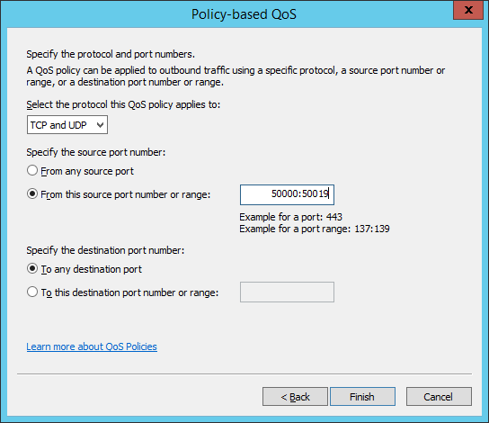
50000:50049
After you have created the QoS policy for audio you will then create a policy for video. To create a policy for video, follow the same basic procedure you followed when creating the audio policy, making these substitutions:
- Use a different (and unique) policy name (for example, Skype For Business Video QoS).
- Set the DSCP value to 34
- Use the source port range for video traffic: 50050:50099.
- Use To any destination port for the destination port.

After you have created the QoS policy for audio and video, you will then create a policy for App sharing and File transfers.
- Use a different (and unique) policy name (for example, Skype For Business App Sharing QoS).
- Set the DSCP value to 24
- Use the port range for App sharing/File transfer traffic: 50100:50149.
- Use To any destination port for the destination port.
After you have created the QoS policy for audio, video and app sharing/file transfers, you will then create 3 policies for Signaling.
- Use different (and unique) policy names (for example, Skype For Business Signaling QoS1, Skype For Business Signaling QoS2, and Skype For Business Signaling QoS3).
- Set the DSCP value to 24
- Use these ports for each of the Signaling Policies: 443 (TCP), 5061 (TCP), 3478 (UDP). Use this port for both the source and destination ports.
When all policies are configured, the Group Policy Object settings should appear like:
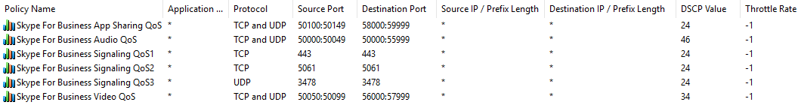
*
*
*

Keep in mind that these policies should be targeted towards your client computers. They should not be applied to servers running Skype for Business Server.
To help ensure that network packets are marked with the appropriate DSCP value, you should also create a new registry entry on each computer by completing the following procedure:
- Click Start and then click Run.
- In the Run dialog box, type regedit and then press ENTER.
- In the Registry Editor, expand HKEY_LOCAL_MACHINE, expand SYSTEM, expand CurrentControlSet, expand services, and then expand Tcpip.
- Right-click Tcpip, point to New, and then click Key. After the new registry key is created, type QoS and then press ENTER to rename the key.
- Right-click QoS, point to New, and then click String Value. After the new registry value is created, type Do not use NLA and then press ENTER to rename the value.
- Double-click Do not use NLA. In the Edit String dialog box, type 1 in the Value data box and then click OK.
- Close the Registry Editor and then reboot your computer.

References: https://technet.microsoft.com/en-us/library/jj205371(v=ocs.15).aspx
https://gallery.technet.microsoft.com/lync/Configure-QoS-for-Skype-cdea2e67
https://technet.microsoft.com/en-us/library/gg425841.aspx

