Ticket Reporting Format for Trouble Tickets
Required Ticket Information
DATE OF ISSUE:
TIME OF ISSUE:
AGENCY:
LOCATION:
PLATFORM (ENHANCED OR BASIC):
USERS AFFECTED:
ORIGINATING DID:
TERMINATING DID:
AGENT NUMBER:
TIME of Call Placed to CCA Server:
CCA Server Caller ID:
BRIEF DESCRIPTION OF ISSUE:
****PLEASE PROVIDE SAMPLE PACKET CAPTURES / LOGS THAT PERTAIN TO ISSUE*****

Process to open a trouble ticket with AT&T Skype for Business services.
**Trouble tickets can only be opened by predefined authorized users for each Agency
- Process to open tickets via the ticketing web portal
  - Open the ATT ticketing web portal assigned for your agency
- DOT - https://sow-dot.attucs.com
- Ethics - https://sow-ethics.attucs.com
- DOA - https://sow-doa.attucs.com
- ETF - https://sow-etf.attucs.com
- DHS - https://sow-dhs.attucs.com
- DOR - https://sow-dor.attucs.com
- Elections - https://sow-elections.attucs.com
- DWD - https://sow-dwd.attucs.com
- DFI - https://sow-dfi.attucs.com
- DHA - https://sow-dha.attucs.com
- HEAB - https://sow-heab.attucs.com
- DSPS - https://sow-dsps.attucs.com
- SFP - https://sow-sfp.attucs.com
- OPD - https://sow-opd.attucs.com
  - Select the Ticket tab from the main menu
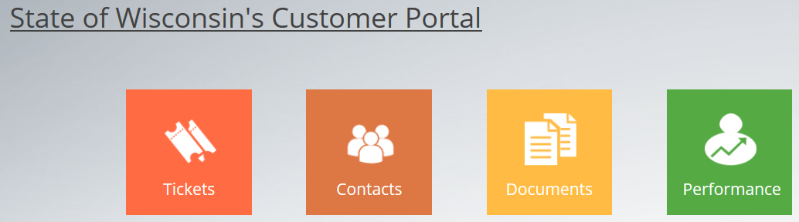
  - From the ticket screen select the “Create Ticket” button near the top right
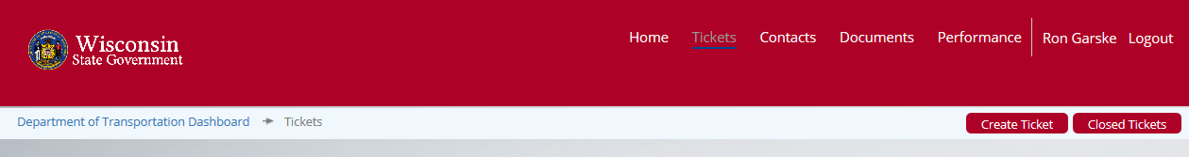
  - Complete the ticket form with your contact information and the required ticket information defined at the beginning of this document.
  - Click the submit ticket button at the bottom of the form.
- Process to open tickets via email
  - Send an email with the required ticket information as described above to wisconsin@attucs.com.
- Process for critical/major service impacts or outages
  - For faster service for critical events call ATT UC Support at 844-423-1130
  - This will ensure faster service for these events
  - Have the required ticket information ready to provide the ATT UC support.
  - Be sure to specify you want this as a Sev1 or Sev2 incident ticket.
  - **Make sure you also open a ticket with ESD so they can assist with the resolution process and create an enterprise event to alert for notification and communications support.
    - Contact ESD by phone at (608) 264-9383 or by email at ESDhelp@wisconsin.gov.
    - It’s always better to call if you have an outage.

