Virtel Getting Started Guide
Version 1.5
February 13th 2019

Table of Contents
- Introduction
- Access to the Mainframe using Virtel
- Determining your current version of Virtel
- System Requirements to use Virtel
- Launching Virtel (Internal access)
- Launching Virtel (External access)

- Introduction
Due to various issues with HOD including java requirements and cost, the Mainframe Services Section at DET has been researching an alternative terminal emulator as a replacement for Host On-Demand (HOD) since early in 2018.
This effort for an Alternative to HOD primarily focused upon, but was not limited to;
- Ease of use – Similar interface to HOD, but without the restriction of the JAVA JRE requirement of HOD.
- Security – elimination of java requirements in order to enhance security since numerous security exposures have been identified in java requiring ongoing updates and patching
- Browser based – eliminates the need for any downloaded software (i.e. Thin client rather than a Thick client), avoiding additional maintenance and complexity of think clients.
- Cost – to reduce on-going reoccurring costs of the product or application.

One such product appears to have met our needs. Virtel Web Access by SDS.
- This product has no PC prerequisites such as JAVA or any other software products to execute on your PC.
- Browser based – It is completely browser based, so as long as you have a browser and internet access, no other software is required on your Operation system to run the emulator.
- Cost – Virtel Web Access is drastically more cost effective than HOD.

In addition, Virtel has been tested by a group of people from multiple agencies and application areas to ensure compatibility and functionality when accessing mainframe applications.

- Access to the Mainframe using Virtel
To access the mainframe using Virtel, there are a few URL’s/Links available;
https://p3270int.wi.gov
https://p3270ext.wi.gov
Where the 1st character designates the environment (eg. p for PROD).
The next four characters identifies the environment (eg. 3720).
The next 3 characters identifies if you are accessing the mainframe from within the state network (eg. int) or externally from the internet (eg. ext).
If you are accessing the mainframe externally, then you would also require a valid WAMS ID with mainframe access in addition to your mainframe user ID (note: This is similar to HOD). In addition, please note that you would need a separate WAMS ID for DEV and for PROD environments.
If your WAMS ID does not have mainframe access, then you would need to coordinate this request with your management and/or security team.
If you do not have a WAMS ID, you would need to go to the following web links, and select the “Self Registration” links on the page and follow the instructions. You will still be required to involve your management and/or security team to complete the process.
http://on.wisconsin.gov To request a WAMS ID for production
http://uaon.wisconsin.gov To request a WAMS ID for UAT

- Determining your current version of Virtel
The current version of the Virtel web based emulator is on the upper right hand side of the toolbar.
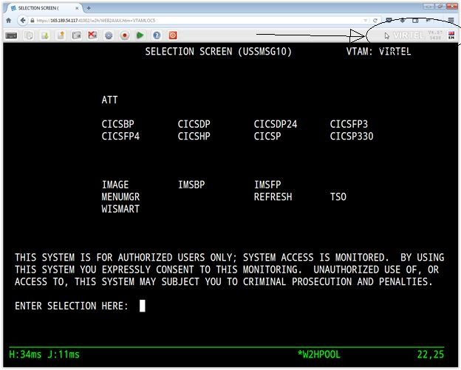

- System Requirements to use Virtel
  - Assumption: we will assume that you will be using the IE (Internet Explorer) browser as we have been using in the past with Host On-Demand (HOD). Even though other browsers are compatible, to identify each browser and specific criteria is beyond the scope of this document due to some of the different aspects and responses of each browser.
  - Operating system capable of supporting the browser of your choice. (In this case, IE resides on the Microsoft Windows OS).
  - Internet access, State network, or access and authorization to connect to the State Mainframe, Including WAMS access where necessary.

- Launching Virtel (Internal access)
  - Open a Browser and point to one of the Internal URL’s listed above in section 2.
(In this example, we are using the production internal link – https://p3270int.wi.gov).
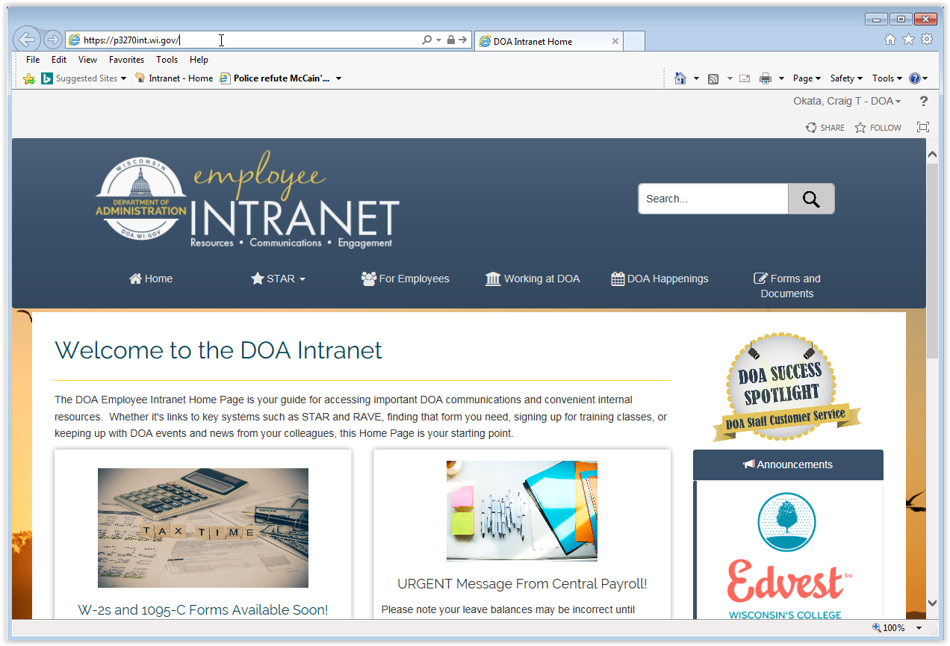
  - Enter your mainframe credentials (i.e. UserID and password), into the pop up dialog box that appears.
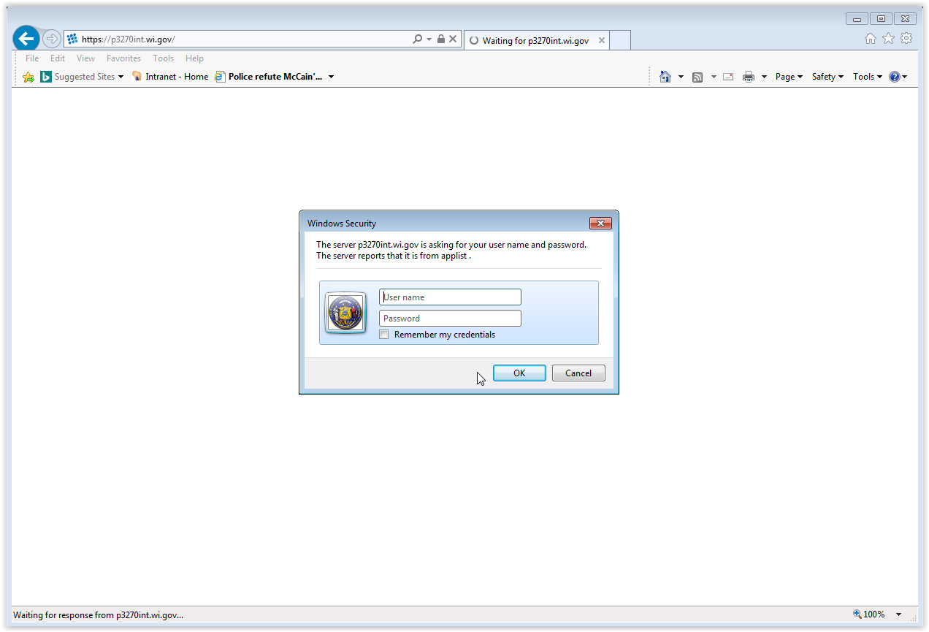
  - Select from the resultant webpage the desired screen size of the mainframe access options.
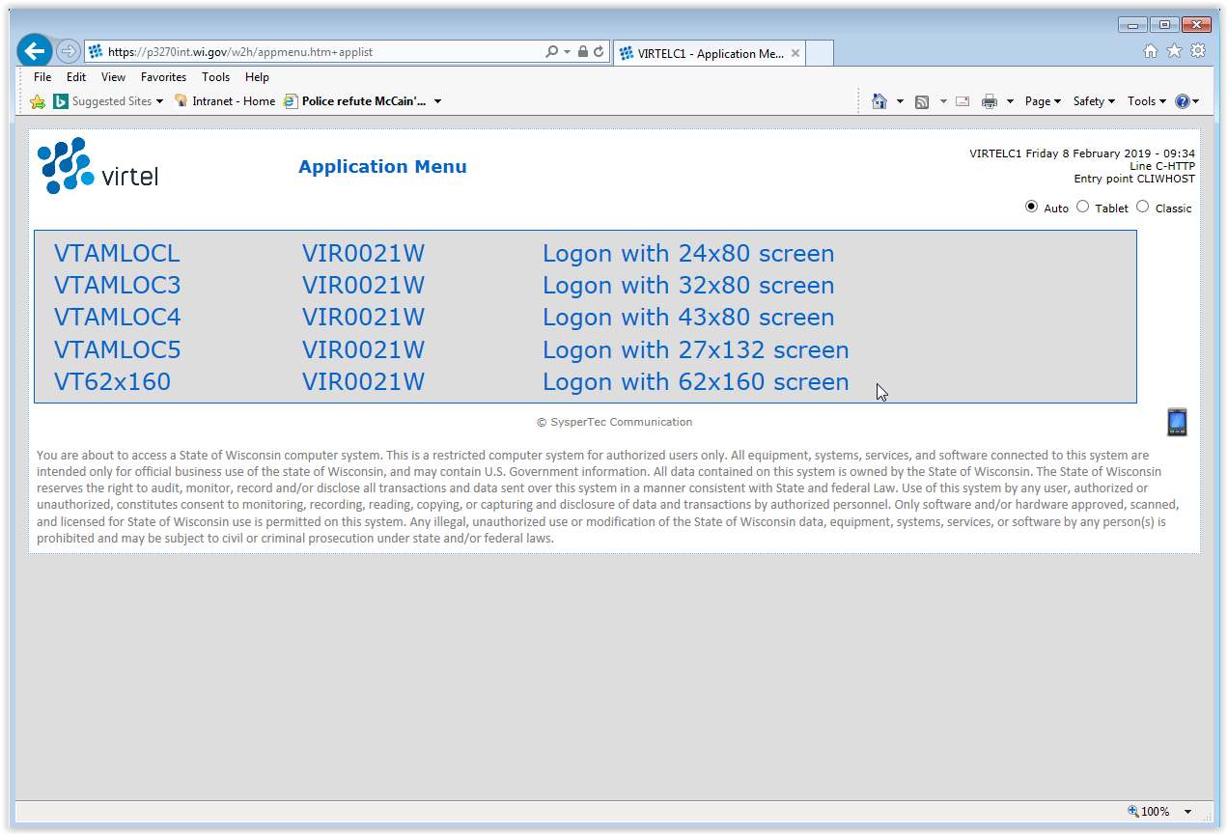
  - The initial mainframe Login screen appears. Login as per your usual method.
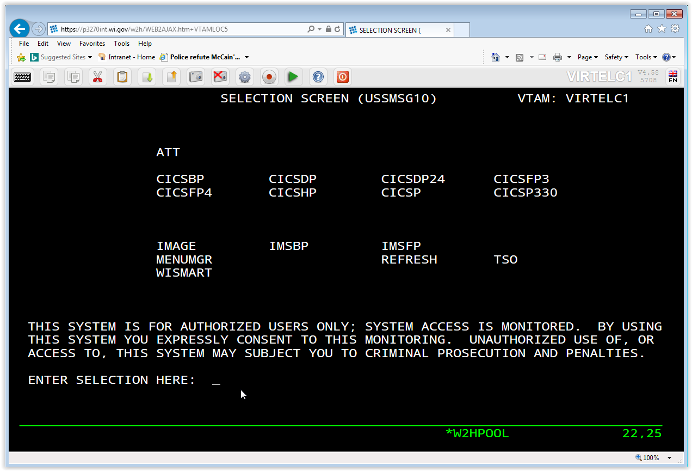

- Launching Virtel (External access)
  - Open a Browser and point to one of the External URL’s listed above in section 2.
(In this example, we are using the production internal link – https://p3270ext.wi.gov).
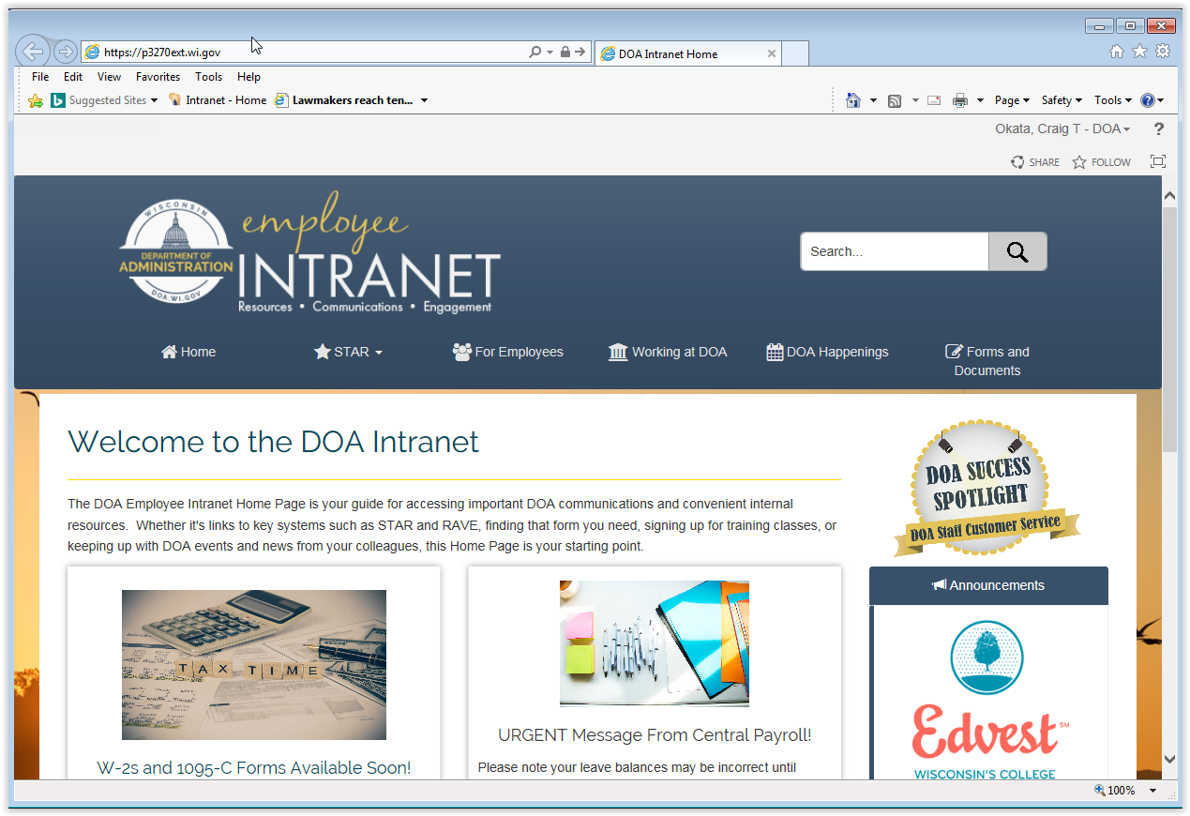
  - Enter your WAMS credentials (i.e UserID and password), into the webpage that appears.
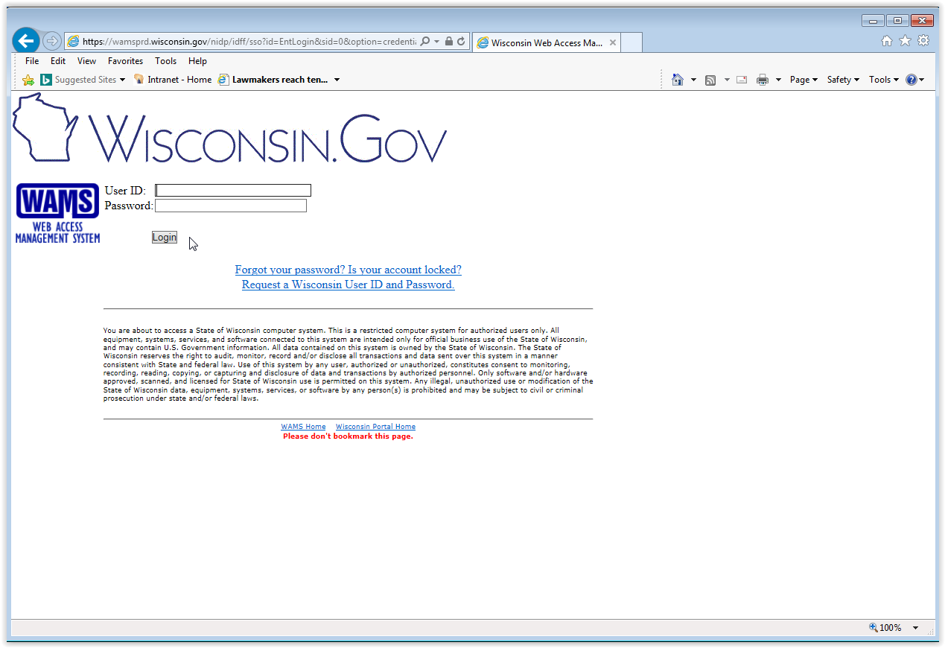
  - Enter your mainframe credentials (i.e. UserID and password), into the pop up dialog box that appears.
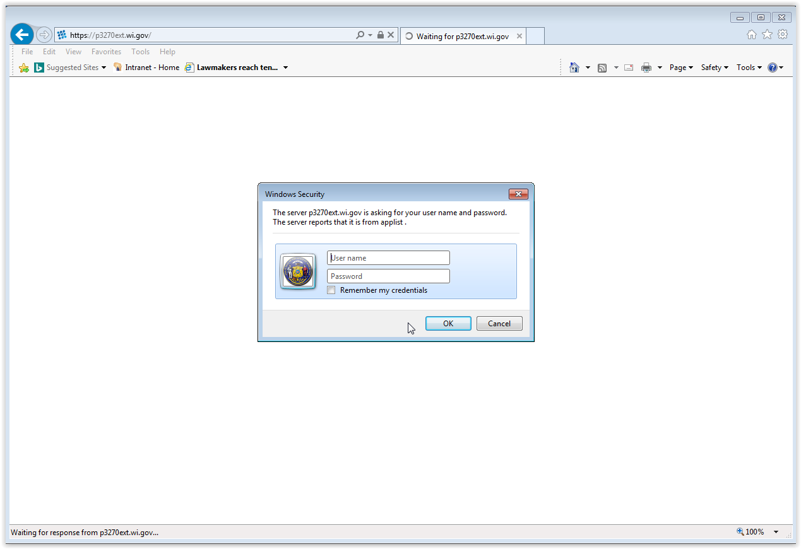
  - Select from the resultant webpage the desired screen size of the mainframe access options.
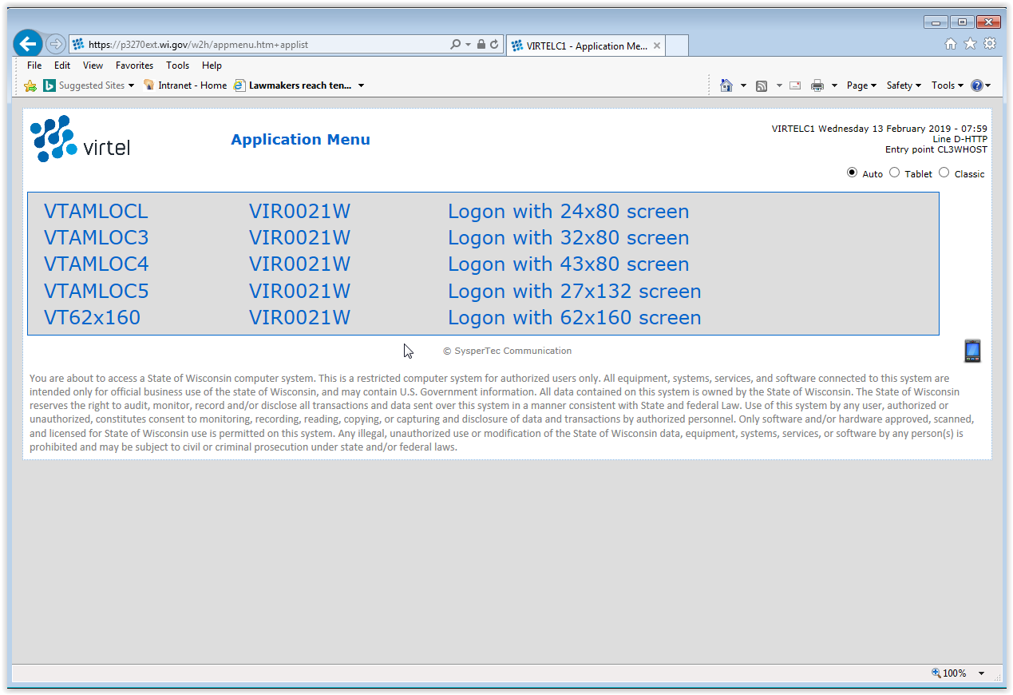

  - The initial mainframe Login screen appears. Login as per your usual method.
