

E-Mail Admin Guide to Exchange 2013 and Exchange On-Line

Table of Contents

A. Enterprise E-mail Management General Information and Definitions 5

A.1 Using This Guide 6

A.2 Definitions 6

A.3 Administrator Roles and Permissions 7

B. Enterprise E-Mail Naming Conventions 9

B.1 Resource Names 10

B.2 Distribution List Names 11

B.3 Shared Mailbox Names 11

C. Accessing Exchange 2013 On-Premise and Exchange On-Line Environments 13

C.1 Connect via Web Browser 14

C.2 Connect via Remote PowerShell: 14

C.3 Connect via Outlook: 16

D. Agency Administrator Functions 21

D.1 Navigating the Microsoft Exchange Admin Center (ECP) 22

D.2 Distribution Groups 24

D.3 Resource Mailboxes 27

D.4 Shared Mailboxes 29

D.5 Contacts 31

D.6 Managing Staff Mailbox Properties 32

Exchange PowerShell and The Agency Powerbook 33

E.1 Exchange PowerBook Information 34

E.2 Exchange Remote Powershell 34

E.3 Common PowerShell One Line Commands 35

F. Additional Exchange Client and Server Features 41

F.1 MailTips 42

F.2 Mailbox Quota Warning Messages 43

F.3 Open Distribution Groups 44

F.4 Mailbox Search and E-Discovery Options 48



# A. **Enterprise E-mail Management General Information and Definitions**

Exchange Server 2013 and Exchange On-Line

**Enterprise E-mail Management General Information, Definitions, Administrator Roles and Permissions**

## A.1 Using This Guide

|  |  |
| --- | --- |
| **Audience** | This Enterprise E-mail Administration Guide is written for Agency E-mail Administrators and Agency Security Administrators who will use the Microsoft Exchange Admin Center (ECP), and/or Exchange Power Shell applications. Agencies will assign staff to the role of Agency E-mail Administrator and/or Agency Security Administrator. |

## A.2 Definitions

|  |  |  |  |
| --- | --- | --- | --- |
| **E-mail Administrators** | E-mail Administrators will be able to manage the e-mail accounts and settings for e-mail specific entities, such as Distribution Lists, Resources, Shared Mailboxes, and Contacts. | | |
| **Security Administrators** | Security Administrators will be able to manage some e-mail related settings on staff mailboxes. IAM will continue to provide the functions it does today for Staff mailbox creation and management. Some additional management functionality will now be available to Security Administrators through the ECP and Exchange PowerShell. | | |
| **Mailbox**  **(Staff user accounts)** | In this system, a “Staff user” is an account that is associated with one physical person. These accounts must be created using the IAM tool following the IAM manual. The Agency Security Admin is now delegated to use the Exchange native tools to make some changes to “staff” accounts. | | |
| **Shared Mailbox** | A Shared Mailbox is a mailbox that is primarily used to send or receive messages, but is not associated directly to a single individual. These mailboxes are associated with disabled AD accounts and cannot be logged into directly. Commonly these are public facing addresses that may be listed on websites, brochures, or other communications to allow the general public or other agencies to communicate on a specific subject. One or more individuals may monitor shared mailboxes. Individuals or groups can be given the rights to “Send-As” or “Send on Behalf of” the mailbox.  In some cases shared mailboxes may require the AD account to be enabled and a password assigned so that a person or an application can ‘log in’ to the mailbox. For those situations, the delegated administrator must contact DET to enable the account and create a password. | | |
| **Resource Mailbox** | A Resource Mailbox is one that is used primarily for calendaring, and can be set to automatically accept appointments, or can have appointment requests sent to a delegate that has to manually accept or reject the requests. Resource Mailboxes that are set to automatically accept appointments will not receive e-mail messages. | | |
| **Distribution List** | A Distribution List is a grouping of e-mail accounts with a display name that can appear in the GAL. Messages can be sent to a Distribution List. Distribution Lists **may** be used for security access to other objects if they are created as Mail-Enabled Security groups. | | |
| **Contacts** | Contacts are entries in the general or agency only GAL that are used to forward messages to someone that does not have a mailbox in the enterprise e-mail system. Contacts may be included in distribution lists. | | |
| A.3 Administrator Roles and Permissions | | | |
| **Security Admin Role** | |  | **E-mail Admin Role** |
| **Recipients category - Staff Mailboxes only** | |  | **Recipients category - MailProv only** |
| * Can add/edit General/custom attributes 10-15 | |  | * Mailboxes - Can create shared mailboxes. Archiving can be enabled. |
| * Can change mailbox features (eg. ActiveSync, litigation hold etc.) | |  | * Add/edit rights to groups |
| * Can add/edit MailTips | |  | * Add/edit rights to resources |
| * Can add/edit mailbox delegation | |  | * Add/edit rights to contacts |
|  | |  | * Add/edit rights to shared |
|  | | | |
| **Permissions category** | |  | **Permissions category** |
| * Can Add and Edit Outlook Web Policies for the agency | |  | * Can Add and Edit Outlook Web Policies for the agency |
|  | | | |
| **Compliance Management** | |  | **Compliance Management** |
| * Can Add In-place eDiscovery and Hold items | |  | * Can Add In-place eDiscovery and Hold items |
| * Can Run audit reports | |  | * Can Run audit reports |
| * Can Add and Edit Retention Policies | |  | * Can Add and Edit Retention Policies |
| * Can Add and Edit Retention Tags | |  | * Can Add and Edit Retention Tags |
|  | | | |
| **Organization** | |  | **Organization** |
| * Can edit the name and order of the Default Sharing Policy | |  | * Cannot edit the policy |
|  | | | |
| **Mail Flow** | |  | **Mail Flow** |
| * Can Run delivery reports | |  | * Can Run delivery reports |
| * Cannot Add or Edit the accepted domains | |  | * Cannot Add or Edit the accepted domains |
|  | | | |
| **Mobile** | |  | **Mobile** |
| * Cannot make any edits to the listed policies | |  | * Cannot make any edits to the listed policies |
|  | | | |
| **Public Folders** | |  | **Public Folders** |
| * No access available at this time | |  | * No access available at this time |
|  | | | |
| **Servers** | |  | **Servers** |
| * Cannot make any edits to the listed servers | |  | * Cannot make any edits to the listed servers |



# B. Enterprise E-Mail Naming Conventions

The Enterprise E-Mail Environment has naming conventions designed to create a consistent structure in the Global Address Book to make it easy for our customers to find staff and non-staff mail objects. Please adhere to the naming conventions. When in doubt, contact DET for guidance.

## B.1 Resource Names

|  |
| --- |
|  |

Each resource in the enterprise has a unique name which is used in the GAL (Global Address List) by which it is identified. In the new Enterprise E-Mail System the naming convention will be changed. The format consists of *three* parts separated by spaces:  
 1) AgencyID 2) ResourceID 3) Description (optional).

As an example, a resource that is currently named *DOA Conf Rm 10D Seats 14-27 would be changed to DOA CR 10D Seats 14-27. This example of the new naming convention assumes that an agency occupies a single building. If an agency occupies multiple State office buildings, the name of the building will also be included in the description part of the name. For example, conference room 041 in the GEF3 building would be named DPI CR 041B GEF3.

The **Agency ID** will be the existing standard abbreviation for an agency up to 7 characters in all upper case followed by a space. “**WI**” will be used when an Enterprise resource is defined in place of the Agency ID.

|  |  |
| --- | --- |
| ***Type of Resource*** | ***Abbreviation*** |
| Calendar | CAL |
| Conference Room | CR |
| Distribution List | DL |
| Laptop PC | LAP |
| Tablet PC | TAB |
| Parking Stall | PRK |
| Printer | PRT |
| Project Room | PR |
| Projectors, Cameras and other Audio Video | AV |
| Room List | RL |
| Security Group | SG |
| Telephones | TEL |
| Training Room / Resource | TR |
| Vehicle | VEH |
| External Contact – Mail Enabled | EXT |
| Paging Device | PGR |
| PC Device (Peripheral) | PCD |
| Lodging | LDG |
| Miscellaneous | MISC |

The **Resource ID** will consist of the abbreviated prefix used to identify the type of resource and the specific name followed by a space.

*Slashes and quotes must be avoided in resource IDs*.

The **Description** (optional) is up to the owner of the resource and is used to clarify the **Resource ID**.

**NOTE**: A contact person **must** be identified in the resource properties for each resource. For a conference room resource it is also helpful to list the number of people the room accommodates, the phone number if the room has a live phone jack, any AV equipment, whiteboards, etc. If the “owner” is different from the “contact”, list them both.

**Resource E-Mail AddressES**

The e-mail address for a resource will be: AgencyIDResourceIDDescription (optional)@Wisconsin.gov*.*

(ex. [DOACR10d@Wisconsin.gov](mailto:DOACR10d@Wisconsin.gov))

**NOTE**: The use of a Description is optional only for Resources.

## B.2 Distribution List Names

|  |
| --- |
| Distribution List names will be AgencyID DL Description. The description part can include a Division ID to help organize the information and make it easy for staff to locate but remember to keep the name short so it will be viewable in the Outlook Global Address List window. Some examples are:  DOA DL DAIT Waukesha Attorneys  DOC DL DAI Wardens  DOC DL All DOC Staff  WI DL Email Administrators  **Security groups**  Distribution Lists that are also Security Groups can be AgencyID SG Description  **Distribution List E-Mail AddressES**  The e-mail address for a distribution list will be A*gencyIDDLDescription@Wisconsin.gov*  (ex. doadldaitwaukeshaattorneys@Wisconsin.gov)  **PUBLIC FOLDERS**  Public Folder display names are to begin with the AgencyID PF Description. |

## B.3 Shared Mailbox Names

|  |
| --- |
| The name for a shared mailbox will be A*gencyIDDescription*  (ex. doa Helpdesk with an e-mail address of doaHelpdesk@Wisconsin.gov or doa Print Center with an e-mail address of doaPRINTCENTER@Wisconsin.gov)  **NOTE:** Agencies can, after migration, provide a friendlier, shorter e-mail address (called a secondary proxy) via Service Request or self-management, but it must still begin with the Agency ID. |



# C. Accessing Exchange 2013 On-Premise and Exchange On-Line Environments

**Accessing Exchange 2013 and Exchange On-Line**

|  |
| --- |
| There are two methods of accessing an Exchange environment to perform administrative functions; the Exchange Admin Center (ECP) and Remote PowerShell. The ECP is a web based GUI interface that is accessible over port 443 and is open to Statenet IP addresses. Remote PowerShell is also accessible over port 80 from within Statenet IP ranges. |
| C.1 Connect via Web Browser |
| To access the **ECP for Exchange 2013 on premise** management functions use the following links:  Production: <https://mail.wisconsin.gov/ecp> use (accounts\e-mail admin account)  Dev: <https://devmail.wi.gov/ecp> use (accountsdev\e-mail admin account)  Due to the way many browsers cache credentials, you should not attempt to login as a different account using the same browser – for example, you should not use Internet Explorer to open the ECP as your admin user and another Internet Explorer session as your mailbox user (unless you open the 2nd one as “InPrivate” browsing in the Tools menu of your IE browser. Most other browsers have a similar feature to separate the permissions.  To access the **ECP for Exchange OnLine** managementfunctions use the following links:  Production or Dev: <https://outlook.office365.com/ecp> This link will redirect you to a Microsoft login page where you will be prompted to pick an account to use.  **To manage Exchange OnLine, you will use your *regular* user account, not your admin account!** Use the appropriate e-mail account email address (John.Smith@wisconsin.gov or John.Smith@devmail.state.wi.us). You will be redirected again to the DET ADFS login page where you can enter your password.  That seems like a lot of redirection, but it is the easiest way to get directly to the ECP in Exchange Online. |

|  |  |  |
| --- | --- | --- |
| C.2 Connect via Remote PowerShell: | | |
| Always open Windows PowerShell using “Run as Administrator”. To connect to one of the environments, copy all of the Login commands from one of the groups below at once and paste them into PowerShell.  **On Premise Exchange 2013 Production:** | |
| **$UserCredential = Get-Credential**  **$Session = New-PSSession -ConfigurationName Microsoft.Exchange -ConnectionUri https://mail.wisconsin.gov/PowerShell/ -Authentication Basic -Credential $UserCredential**  **Import-PSSession $Session -DisableNameChecking**  **$FormatEnumerationLimit = -1**  **Set-AdServerSettings -ViewEntireForest $True**  **On Premise Exchange 2013 Development:**  **$UserCredential = Get-Credential**  **$Session = New-PSSession -ConfigurationName Microsoft.Exchange -ConnectionUri https://devmail.wi.gov/PowerShell/ -Authentication Basic -Credential $UserCredential**  **Import-PSSession $Session -DisableNameChecking**  **$FormatEnumerationLimit = -1**  **Set-AdServerSettings -ViewEntireForest $True**  **Exchange On-Line**  **$UserCredential = Get-Credential**  **$Session = New-PSSession -ConfigurationName Microsoft.Exchange -ConnectionUri https://ps.outlook.com/PowerShell/ -Authentication Basic -AllowRedirection -Credential $UserCredential**  **Import-PSSession $Session -DisableNameChecking**  **$FormatEnumerationLimit = -1** | |
| When you run any of the above scripts, a Windows login box will open prompting you to enter your credentials.  **For On Premise Exchange**, use your agency E-mail Administrator account.  [Accounts\*******] or [Accountsdev\*********]  **For Exchange On-Line**, use your regular user E-mail address  [john.smith@wisconsin.gov] or [john.smith@devmail.state.wi.us] |  |
| .  When you are finished using the Remote PowerShell session, disconnect from the remote Exchange Server by running this command:  **Remove-PSSession $Session**  **Exit** | |

|  |
| --- |
| C.3 Connect via Outlook: |

**Create an Outlook Profile in the Exchange Server 2013 Environment**

Always use the Profile wizard to create an Outlook profile. Microsoft DOES NOT recommend creating Outlook profiles manually.

When you launch Outlook for the first time, the profile wizard will automatically prompt you to create an Outlook profile. Depending on your Agency’s deployment of Outlook, you may or may not be prompted to give your Outlook profile a name.

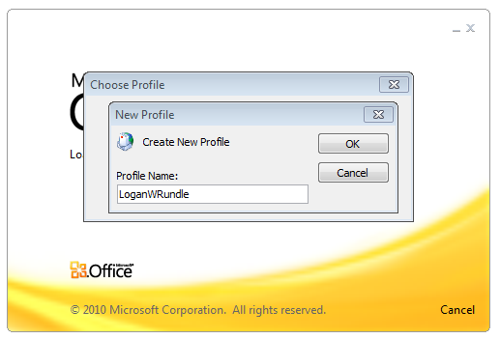

On the Auto Account Setup screen, the wizard will populate the email address field. **Unless your agency has been consolidated into the Accounts domain, you will have to change the information on this screen!** Clear all the auto-populated entries and enter your email address and password. Click Next.

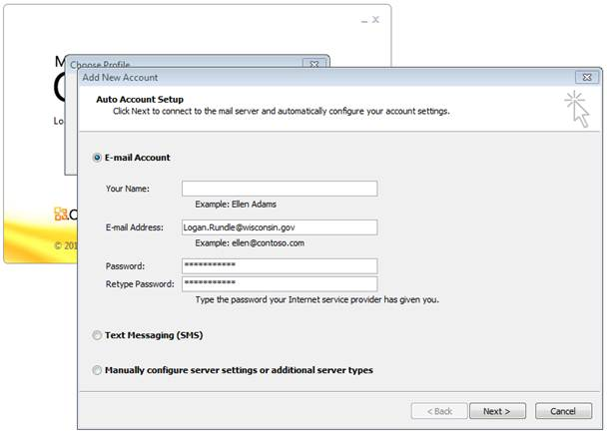

When your Account has been successfully configured, you should check to ensure the security requirements are set correctly. Check the box next to **Change account settings**.Click Next.

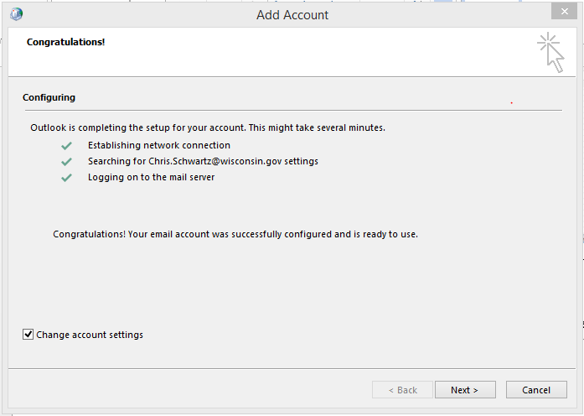

Click the **More Settings** button.

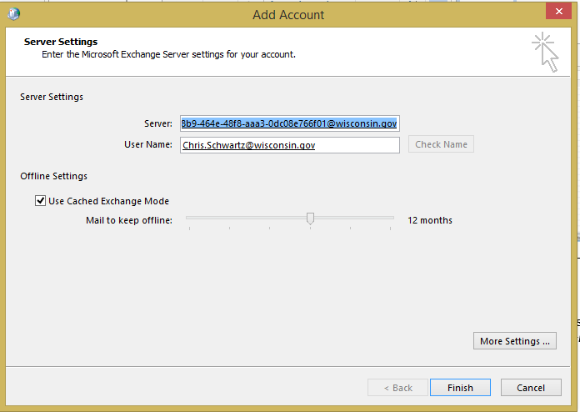

Click on the Security tab to ensure the settings are correct for your environment.

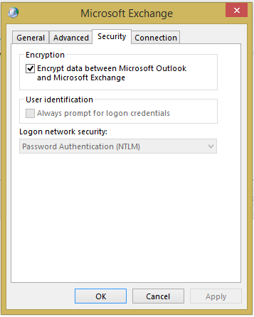

Under the User identification section, ensure that the checkbox for Always prompt for logon credentials **is checked** if your agency has not been consolidated into the Accounts domain.

All agencies should have the Logon network security setting set to Password Authentication (NTLM).

Click OK to return to the Add Account screen. Then click Finish

If your agency is not consolidated into the Accounts domain, you will be prompted for your credentials a second time.

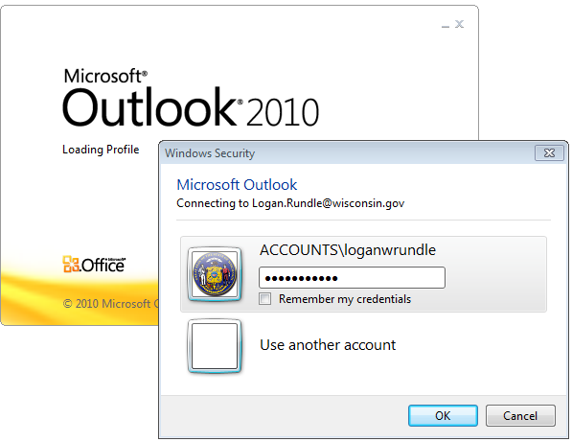

You have now successfully created an Outlook profile and have access to your mailbox.

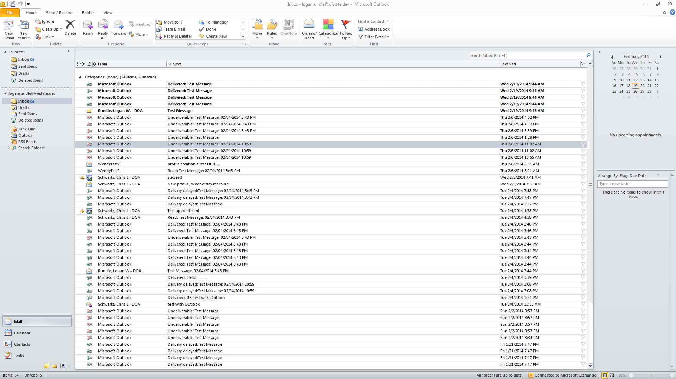

NOTE: The Security tab settings “Always prompt for logon credentials” and the Logon network security: “Password Authentication (NTLM)” are required for all Outlook Clients from agencies that are not consolidated into the Accounts domain. These settings can be pushed through GPO.



# D. Agency Administrator Functions

**Agency Administrator Functions**

Agency delegated Administrators are responsible for managing the agency Staff and non-Staff, or MailProv, Exchange objects. Delegation is set up so that the agency administrators can fully manage agency accounts through the Exchange Control Panel (ECP) or through Exchange Remote PowerShell.

## D.1 Navigating the Microsoft Exchange Admin Center (ECP)

|  |
| --- |
|  |

The first screen defaults to the **recipients** category. Tabs across the top of the page allow you to see the types of recipients you can view or manage.

The **mailboxes** tab will show all enabled Staff user mailboxes and MailProv user mailboxes. The other tabs across the top will show **groups** (distribution), **resources**, **contacts**, and **shared** (Exchange 2013) mailboxes. The **migration** tab will show migration batches for mailboxes moving to Exchange 2013.

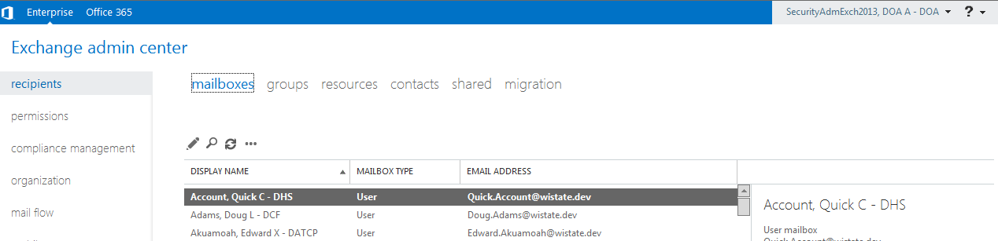

By default, the display will list only 50 items per page (use the scroll bar to see all 50 items). At the bottom of the screen, you can change that number to 500 per page. It can take a while to discover all the items in the category. The total number of items will be shown at the bottom of the screen. If there are more results than are initially returned, there will be a link to Get All Results.

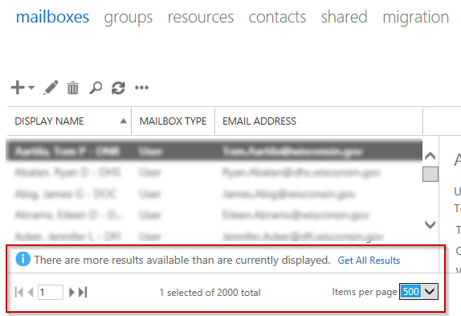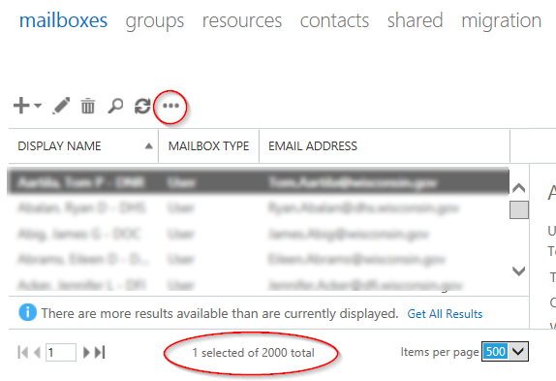

NOTE: The maximum number of results that can be returned in the ECP is 20,000. This is not necessarily in any specific order so you may not get all of the results for your agency.

Each link on the left will take you to a different section of the ECP. Depending on the level of delegated permissions granted to your account, you may not see all of the links shown here.

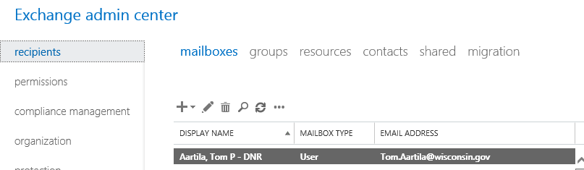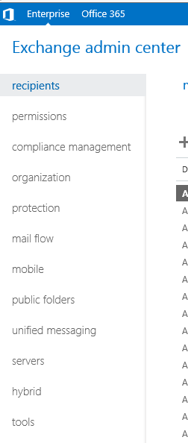The most commonly used links for delegated administrators are **recipients and compliance management.**

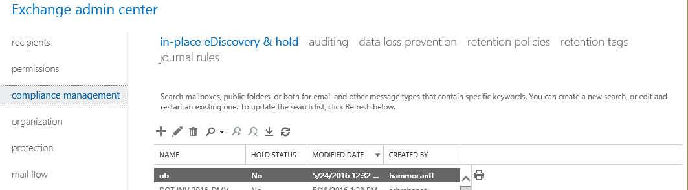

The options that are visible in the Exchange Admin Center (ECP) will be different depending on the rights assigned to the account you are using. Some options will only be visible to accounts assigned to the Agency E-mail Administrator role, and others will be only visible to accounts assigned to the Agency Security Administrator role.

Most screens have standard icons for the actions that are available.



The **+** sign is to create a new item, the pencil is to delete an item, the trash can is to delete an item, the magnifying glass is to search, the circular arrows are to refresh the view, the ellipse (….) indicates that there are more options available.

Since accounts are not restricted to seeing only the accounts in their agency, use the search box to limit your results. Watch for notations at the bottom of the screen showing additional pages of information, a notification that more results are available than are displayed, etc.

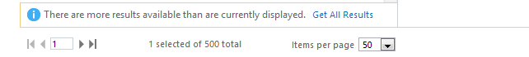

Also check for More options…, which will appear on some screens to show more information or options.

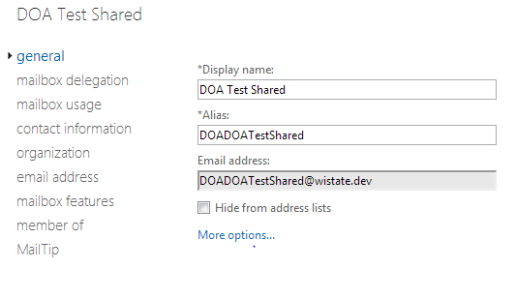

Agency delegated E-mail Administrators can create and manage MailProv objects only. Agency delegated Security Administrators have delegation to manage Staff objects only. This section focuses on the functions that E-mail Administrators routinely perform.

E-Mail Administrators should not create mailboxes using the **mailboxes** tab, so we skip that in this section.

## D.2 Distribution Groups

|  |
| --- |
|  |

From the Exchange Admin Center **recipient** menu,select the **groups** tab.

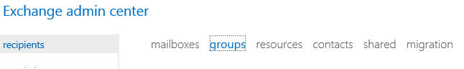

Select **+**. That will give you the option to create three types of groups. The choices are a Distribution Group (DL), Security Group (SG) or a Dynamic Distribution Group (DDG).

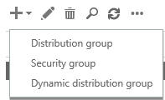

A regular Distribution Group is designed to simplify sending a message to a group of mailboxes.

An Exchange Security Group can be used to send mail to a group of mailboxes and can also be used to give the group members access rights to other mailboxes.

A Dynamic Distribution Group will re-create the membership every time it is used based on a specific criteria, such as all accounts in a certain Organizational Unit, or all accounts within that OU that have a certain Custom Attribute set.

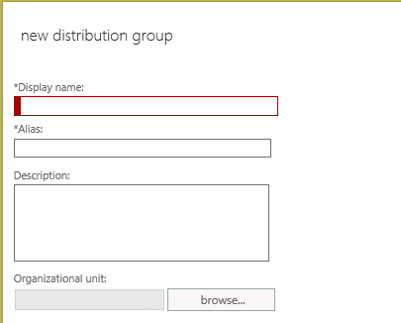

Regardless of the type of group you want to create, you must provide the DisplayName and Alias.

Be sure to follow the Enterprise Email naming standards when naming the group

Browse to select the appropriate Organizational Unit for this Distribution Group.  
(Accounts/MailProv/Agency/DLs)

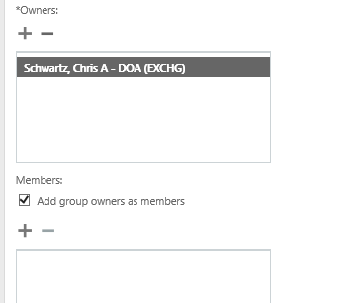

An Owner is required for Exchange Distribution Groups and Mail Enabled Security Groups.

Members can be added at the time of group creation.

The options for Distribution Groups have been greatly expanded in Exchange 2013.

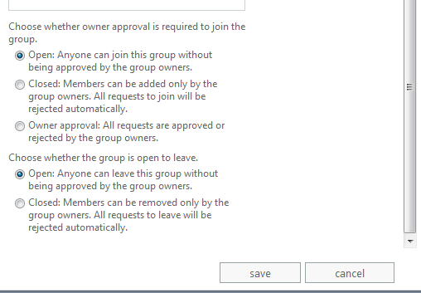

Regular Exchange Distribution Groups can be set up to allow people to add or remove themselves automatically rather than requiring a manager to add or remove them.

See Section F2 for more information on self-subscribing Distribution Groups.

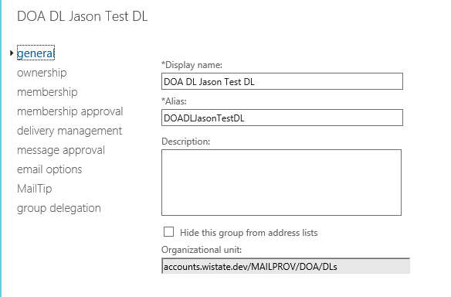After a group is created, most fields can be changed or updated under the Edit  option.

You must populate Custom Attribute 2 using PowerShell because there is no way to edit Distribution Group custom attributes in the ECP. CA2 MUST be filled in for the email address policy to populate the primary SMTP address correctly.   
  
Set-DistributionGroup <group alias> -CustomAttribute2 <Agency Acronym>

## D.3 Resource Mailboxes

|  |
| --- |
|  |

From the Exchange Management Console **recipients** menu choose the **resources** tab.

Click **+** to create a new Resource. There will be a choice of two types of Resources: Room mailbox (CAL, CR, PR etc.) or Equipment mailbox (AV, TEL, VEH etc.).

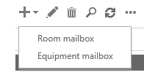

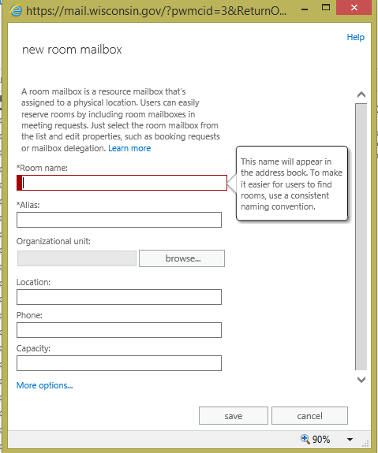

The fields for entry have explanation helper menus.

Please follow the Enterprise Naming Standards when naming Resources.

**Browse** to select the correct Organizational Unit, making sure to select the “ResourceMBXs” OU for your agency

Click on **More Options** to have access to all of the fields available.

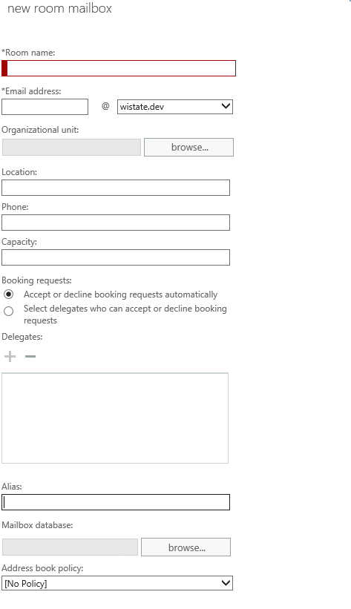

You can configure Auto Accept and delegate features on the resource at initial setup.

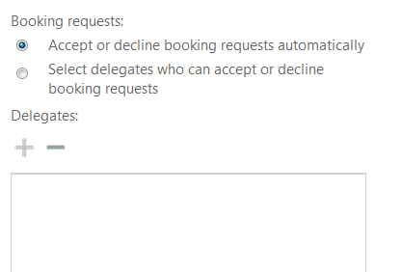

The only mailbox database available for Resource creation is the OnMailProv mailbox store. It can be browsed to, or it will be created there by default if left blank.

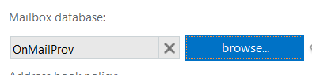

You must populate Custom Attributes 1 and 2 after you create the mailbox by editing the properties, clicking on More Options, then clicking on the pencil icon to add CA1 and CA2. CA2 MUST be filled in for the email address policy to populate the primary SMTP address correctly.

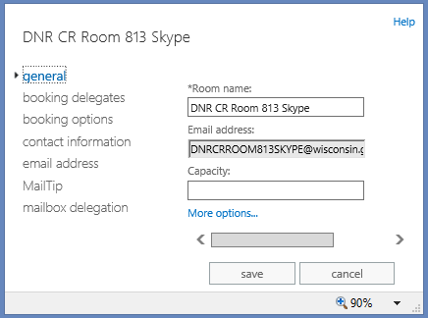 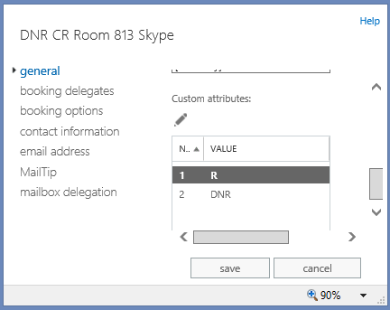

## D.4 Shared Mailboxes

|  |
| --- |
|  |

Shared mailboxes are often used for agency general information, program area, or help desks, where all mail can be sent to a single mailbox and multiple staff can manage it or respond.

Shared mailboxes can be managed by one or more staff members to view and respond to e-mail messages. Permission to ‘Send As’ the Shared mailbox can be granted to staff who manage the mailbox.

Shared Mailbox calendars should not be used for scheduling meetings or equipment. Create a Resource mailbox for those functions.

Share Mailbox accounts are ‘disabled’ by default and there is no password required. If the mailbox needs to be logged into by a program (CCA, ActiveSync, etc.) it should be set up as a MailProv user mailbox with a password instead of a Shared mailbox. Shared mailboxes provide the use of the shared e-mail address, without the risk of sharing the passwords and needing to change it when staff change, and being able to determine who actually sent the message “from” the shared mailbox.

From the Exchange Admin Center recipients menu, select the **shared** tab.

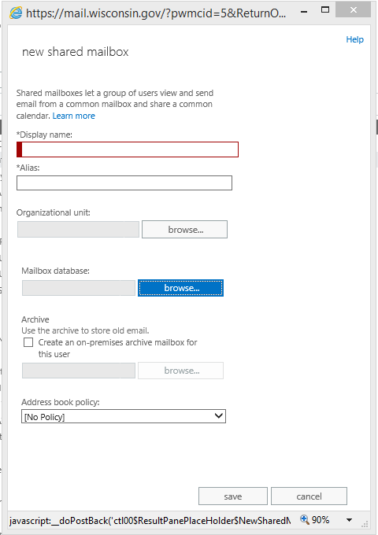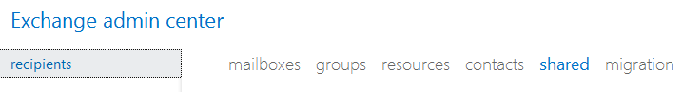

Click on More Options to expand the dialog box and display all settings as shown here.

Follow the Enterprise Naming standards when assigning a Display name.

Use the Browse button to select the correct SharedMBXs OU.

Use the Browse button to choose the OnMailProv database.

Click Save, then Edit the new mailbox configure additional settings such as Custom Attributes and mailbox delegation.

Select the staff or security groups that should have full access to read and manage the mailbox and the staff or groups that should be allowed to “Send-As” the shared mailbox. Only mail enabled security groups will be available for permissions.

Like the other objects, you can use the pencil icon  to edit a new or migrated Shared Mailbox.

You must populate Custom Attributes 1 and 2 after you create the mailbox by editing the properites, clicking on More Options, then clicking on the pencil icon to add CA1 and CA2. CA2 MUST be filled in for the email address policy to populate the primary SMTP address correctly.

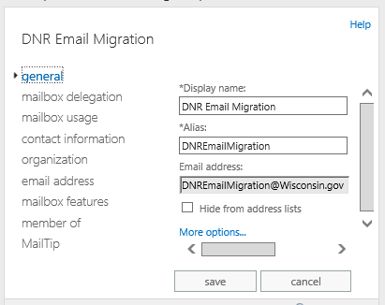 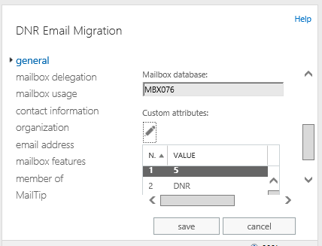

## D.5 Contacts

|  |
| --- |
|  |

From the Exchange Admin Center, recipients menu, select **contacts**.

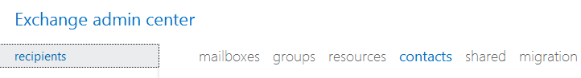

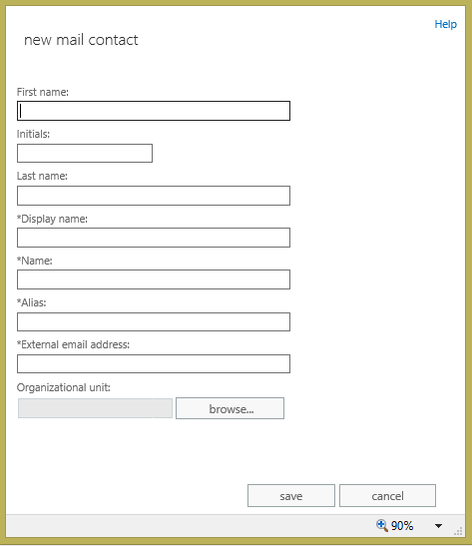Click on **+** to create a new contact.

Populate the contact information. Required fields are noted with an asterisk.

The Alias and the External E-mail address field cannot have the same value as another contact or internal mailbox.

Click the **browse…** button to the right of Organizational Unit (OU) and navigate to your agency Contacts OU under MailProv.

Click Save.

Contacts do not require a Custom Attribute 2 entry to denote the Agency, however, filling in the Department Field on the organization screen or the Notes field on the contact information screen of the Mail Contact object helps to identify which agency created the contact.

## D.6 Managing Staff Mailbox Properties

|  |
| --- |
|  |

Most of the properties of Staff mailboxes are managed through the IAM admin tool, UMRA, and are blocked from editing in Exchange. Through the Exchange Control Panel (ECP) and using PowerShell commands you can change a subset of mailbox properties.

* Add/Modify/Remove **Custom Attributes 10 – 15** (Custom Attributes 1-9 are reserved)
* Add/Modify/Remove **Proxy E-mail addresses**   
   (Changes to the Primary SMTP address must be done in UMRA.
* Select **Retention Policy** from available choices
* Enable/Disable **ActiveSync**
* Select **Mobile device mailbox policy** from available choices
* Add/Modify/Remove **Mobile device** pairings
* Enable/Disable **Outlook Web App**
* Enable/Disable **IMAP**
* Enable/Disable **POP3**
* Enable/Disable **MAPI\*\***
* Enable/Disable **Litigation hold**
* Manage **Delivery Options** (mail forwarding)
* Manage **Message Delivery Restrictions**
* Add/Modify/Remove **MailTips**
* Set **Mailbox Delegation** (Full Access, SendAs, SendOnBehalfOf)

**\*\*Disabling MAPI will prevent a user from accessing their e-mail through the Outlook Client. Be careful that you do not disable this feature by accident.**



# Exchange PowerShell and The Agency Powerbook

## E.1 Exchange PowerBook Information

|  |
| --- |
|  |

Some administrative functions cannot be performed in the Exchange Admin Center and therefore must be completed with PowerShell. In addition, some functions are more efficient to run in PowerShell. To help get you started, we have created the Agency PowerBook. The PowerBook is an Excel workbook with some of the common PowerShell commands set up to accept input from the agency administrator and create the PowerShell command. These are basic commands and other commands or parameters for these commands may be required to meet your business needs.

The current Agency Exchange 2013 PowerBook can be found on the E-mail Governance SharePoint site <https://agency.wisconsin.gov/sites/doadet/Enterprise/emailgovernance/default.aspx> in [Shared Documents](https://agency.wisconsin.gov/sites/doadet/Enterprise/emailgovernance/Shared%20Documents/Exchange%202013%20E-Mail%20Admin%20Documentation). The document will be updated periodically, so always check for the latest version.

The first tab has an index of the available commands, with a brief explanation for what they will be used for. Each description links to a tab that has the command with one or more parameters to input, then just copy the resulting script and run it in an Exchange 2013 Remote PowerShell.

In some cases, there will be additional options available in the Exchange Admin Center (ECP) that are not in the PowerBook, such as setting the ability for staff to join and remove themselves from Distribution Lists. These settings can be included in the PowerShell command line, but don’t fit the format of the PowerBook for easy input. You can get more information about any of the commands by typing in “help <PowerShellcommand> -full in a Remote PowerShell session, or by looking at the Microsoft TechNet site.

<http://technet.microsoft.com/en-us/library/bb124413(v=exchg.150).aspx>

|  |
| --- |
| E.2 Exchange Remote Powershell |
|  |

Exchange 2013 management provides robust management tools via the PowerShell command line interface. The Exchange Admin Center (ECP) is a web interface that performs PowerShell commands in the background.

The Exchange Admin Center is convenient for some commands and simple daily tasks, but PowerShell is more convenient, and sometimes essential, for more advanced commands or bulk processes.

The PowerShell language is comprised of nouns and verbs at the simplest level, arranged into cmdlets. One convenient conventions of PowerShell is the ‘pipe’. **"|"** being the pipe character is normally located above the **"\"** on the keyboard. It can be used to send the output of one command to another command. For example (this works in any command shell, not just PowerShell), **“| more”** will pause the output after each screen to let you see it before it scrolls off.

Other convenient conventions are **>** which will redirect the output to a text file and **>>** which will append the output to the file. In PowerShell, you can use | ft to send selected output to a table, or | fl to send output to a list view.

Tab completion reduces the number of keystrokes that are required to complete a cmdlet. Just press the **TAB** key to complete the cmdlet you are typing. Tab completion kicks in whenever there is hyphen **(-)** in the input. For example: Get-Send

should complete to Get-SendConnector after you press the Tab key . You can even use regular expressions, such as:

**Get-U*P\*** Pressing the TAB key when you enter this command cycles through all cmdlets that match the expression, such as the Unified Messaging Mailbox policy cmdlets. When cycling through a list, **SHIFT+TAB** will go back one.

One other useful parameter is **"-resultsize unlimited"**. The *ResultSize* parameter specifies the maximum number of results to return. If you want to return all mailboxes that match the query, use "unlimited" for the value of this parameter. The default value is 1000. You would want to include “-resultsize unlimited” if your query could result in more than 1000 answers and you need all matching answers. In addition, the first 1000 responses are not in an alphabetical or hierarchial manner, so you may only see 3 of the results you expect if you do not increase the number of results to return. For example, if you only have access to see objects in the DOA Mailprov OU, but of the first 1000 objects it grabs, 997 of them are in OUs that you do not have rights to see, your result would only be 3, although you know there are many more results you expected.

Fortunately there is much information available on the Internet concerning PowerShell. We have listed only a few basic commands you might need on a regular basis. This is not an exhaustive list, and the real power of PowerShell is the ability to script routine functions.

WARNING: PowerShell is a very powerful tool and therefore caution should be exercised when running command that are not ‘Get-‘ commands.

## E.3 **Common PowerShell One Line Commands**

|  |
| --- |
| **Reminder:**  **The E-mail Admin Role can only run commands that modify MailProv objects.**  **The Security Admin Role can only run commands that modify Staff Objects.** |

**General Commands**

Get help on a specific command

List all parameters for a cmdlet

Help <cmdlet-name>

Get a list of all commands executed during the PowerShell session and send to a file

Get-Command <cmdlet-name> | Format-List Definition

Displays information about Windows PowerShell cmdlets and concepts

Get-history | fl > <path name.txt>

Get-help

**User Commands**

|  |
| --- |
|  |

View proxies on an account

get-mailbox <user_alias> | fl name, primarysmtpaddress, emailaddresses

Can also be used with SendAs and SendOnBehalfOf

Determine which mailboxes a specific user has permissions to

**Mailbox Commands**

Get-Mailbox -ResultSize Unlimited | Get-MailboxPermission -User <Active Directory User> | fl Identity, AccessRights, Deny > <path name.txt>

|  |
| --- |
| View permissions on a mailbox and write out to a text file  get-mailboxpermission <mailboxnamealias> | fl > <path and file name> |

Grant ‘Send As’ rights on a mailbox

Grant ‘Full Mailbox’ rights on a mailbox

Add-MailboxPermission -Identity <targetmailboxalias> -User <user_alias> -AccessRights SendAs

Grant ‘Send on Behalf of’’ rights

get-mailbox <mailbox alias> | add-mailboxpermission -user <user alias> -AccessRights FullAccess

View all mailboxes size class in your OU

get-mailbox <mailbox alias> | set-mailbox -grantsendonbehalf <user alias>

View a mailbox size and status

get-mailbox -organizationalunit "accounts.wistate.us/staff/xxxx" -sortby displayname | ft -autosize displayname, customattribute1 > <path name.txt>

Restrict who can send to a mailbox

get-user <user_alias> | Get-Mailboxstatistics | select DisplayName,TotalDeletedItemSize,TotalItemSize

Export mailbox data to folder in another mailbox (must grant full mailbox rights first)

Set-Mailbox -Identity <useralias> -AcceptMessagesOnlyFrom <user_alias>,<user_alias> -AcceptMessagesOnlyFromDLMembers <DL_alias>

export-Mailbox -Identity <MailboxIdParameter> -TargetFolder <String> -TargetMailbox <MailboxIdParameter>

View statistics for a mailbox (DisplayName, ItemCount, LastLoggedOnUserAccount, LastLogoffTime, LastLogonTime, StorageLimitStatus, TotalDeletedItemSize, TotalItemSize, database, server, etc.)

Hide a mailbox from the GAL

Get-mailboxstatistics <mailboxalias> | fl

Un-hide a mailbox in the GAL

Get-user <mailboxalias> | set-mailbox -hiddenfromaddresslistsenabled $true

View security permissions for all on a particular mailbox

Get-user <mailboxalias> | set-mailbox -hiddenfromaddresslistsenabled $false

View all users who have ‘Full Access’ to a particular mailbox

get-mailbox <user_alias> | get-adpermission | fl

Determine what permissions a user account has on a specific mailbox

Get-Mailbox <mailboxalias> | Get-MailboxPermission -User <user_alias>

Get-MailboxPermission <mailboxalias> | where {$_.AccessRights -like "*FullAccess*"} | fl

Retrieve information about the folders in a specified mailboxes

Get-MailboxFolderStatistics <user_alias> | ft -wrap

View full details on a user’s mailbox

Get-mailbox <user_alias> | fl

Find all mailboxes in your OU over their quota

get-mailbox -resultsize unlimited -organizationalunit <your_OU_name> | get-MailboxStatistics | where {"IssueWarning","ProhibitSend","MailboxDisabled" -contains $_.StorageLimitStatus} | format-Table DisplayName,TotalItemSize > <path name.txt>

Distribution List/Group Commands

|  |
| --- |
| Add a member to a distribution list |

Add-DistributionGroupMember <dl alias> -Member <member alias>

Restrict who can send to a DL

Set-DistributionGroup -Identity <DL_alias> -AcceptMessagesOnlyFrom <user_alias>,<user_alias> -AcceptMessagesOnlyFromDLMembers <DL_alias>

Allow non-authenticated accounts to send to a DL

Set-DistributionGroup -Identity <DL_alias> -RequireSenderAuthenticationEnabled $false

Show the membership of a DL and export to a text file

Gdlet-distributiongroupmember <dl_alias> | ft > <path name.txt>

Show the details of a DL

Get-distributiongroup <dl_alias> | fl

Set manager permissions on a DL

Get-DistributionGroup <dl alias> | Set-DistributionGroup –ManagedBy <manager alias(es)>

**Note: To make changes to a Distribution List for which you are not a manager, add this parameter:  
“-BypassSecurityGroupManagerCheck” at the end of your command.**

Resource Commands

|  |
| --- |
| http://technet.microsoft.com/en-us/library/dd335075%28v=exchg.150%29.aspx |

Grant ‘Full Mailbox’ rights on a resource mailbox

get-mailbox <mailbox alias> | add-mailboxpermission -user <user alias> -AccessRights FullAccess

Set basic auto-accept on a resource

set-CalendarProcessing -Identity <mailboxalias> -AutomateProcessing AutoAccept

Remove basic auto-accept on a resource

set-CalendarProcessing -Identity <mailboxalias> -AutomateProcessing:None

View auto-accept settings

get-CalendarProcessing <mailboxalias> | fl

Convert a user mailbox to a room types

set-Mailbox <mailboxalias> -Type Room

Piping your get- data to format-table or ft will create a table format showing limited data. Piping it to format-list or fl will list all the get- results. Quite often, there is more data than will stay in the window buffer. Piping that to more will stop the display when a screen if full. Then use the space bar to see the next screen or the enter key to see the next line.

For instance:

**get-mailbox <user alias> | fl | more**

Many times it is more beneficial to export in CSV format. That can be accomplished by piping your data to export-csv command and a file location.

For instance:

**get-mailbox <user alias> | export-csv “c:\temp\sample.csv” –nt**

You can display the data in a browser window and filter that data using the window. You can also select all data and paste into an Excel spreadsheet.

For instance:

**get-mailbox -resultsize unlimited -organizationalunit <your_OU_name> | Select * | Out-Gridview**



# F. Additional Exchange Client and Server Features

|  |
| --- |
| F.1 MailTips |

MailTips are informative notification messages that help you avoid common mistakes. Exchange Server 2013 analyzes a message and if it detects a potential problem, it notifies the user prior to sending the message.

MailTips are supported and will display in the Outlook Client and in the Outlook Web Application.

In an open mail message, a set of messages will be displayed depending on the selected MailTips options. For example, alerts will be displayed if replying to a large number of recipients, sending sensitive information outside of your organization (if configured), or sending a message to someone who is out of the office.

While composing an e-mail in Outlook, the alert(s) will be displayed above the e-mail address(es).



While composing an e-mail in OWA, the alert(s) will be displayed above the e-mail address(es), similar to the Outlook Client.

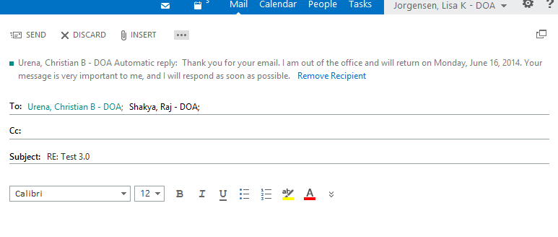

Mailbox owners can manage the options for MailTips through the Outlook client.

**Configuring the MailTips Options in Outlook**

Select the **File** Tab. 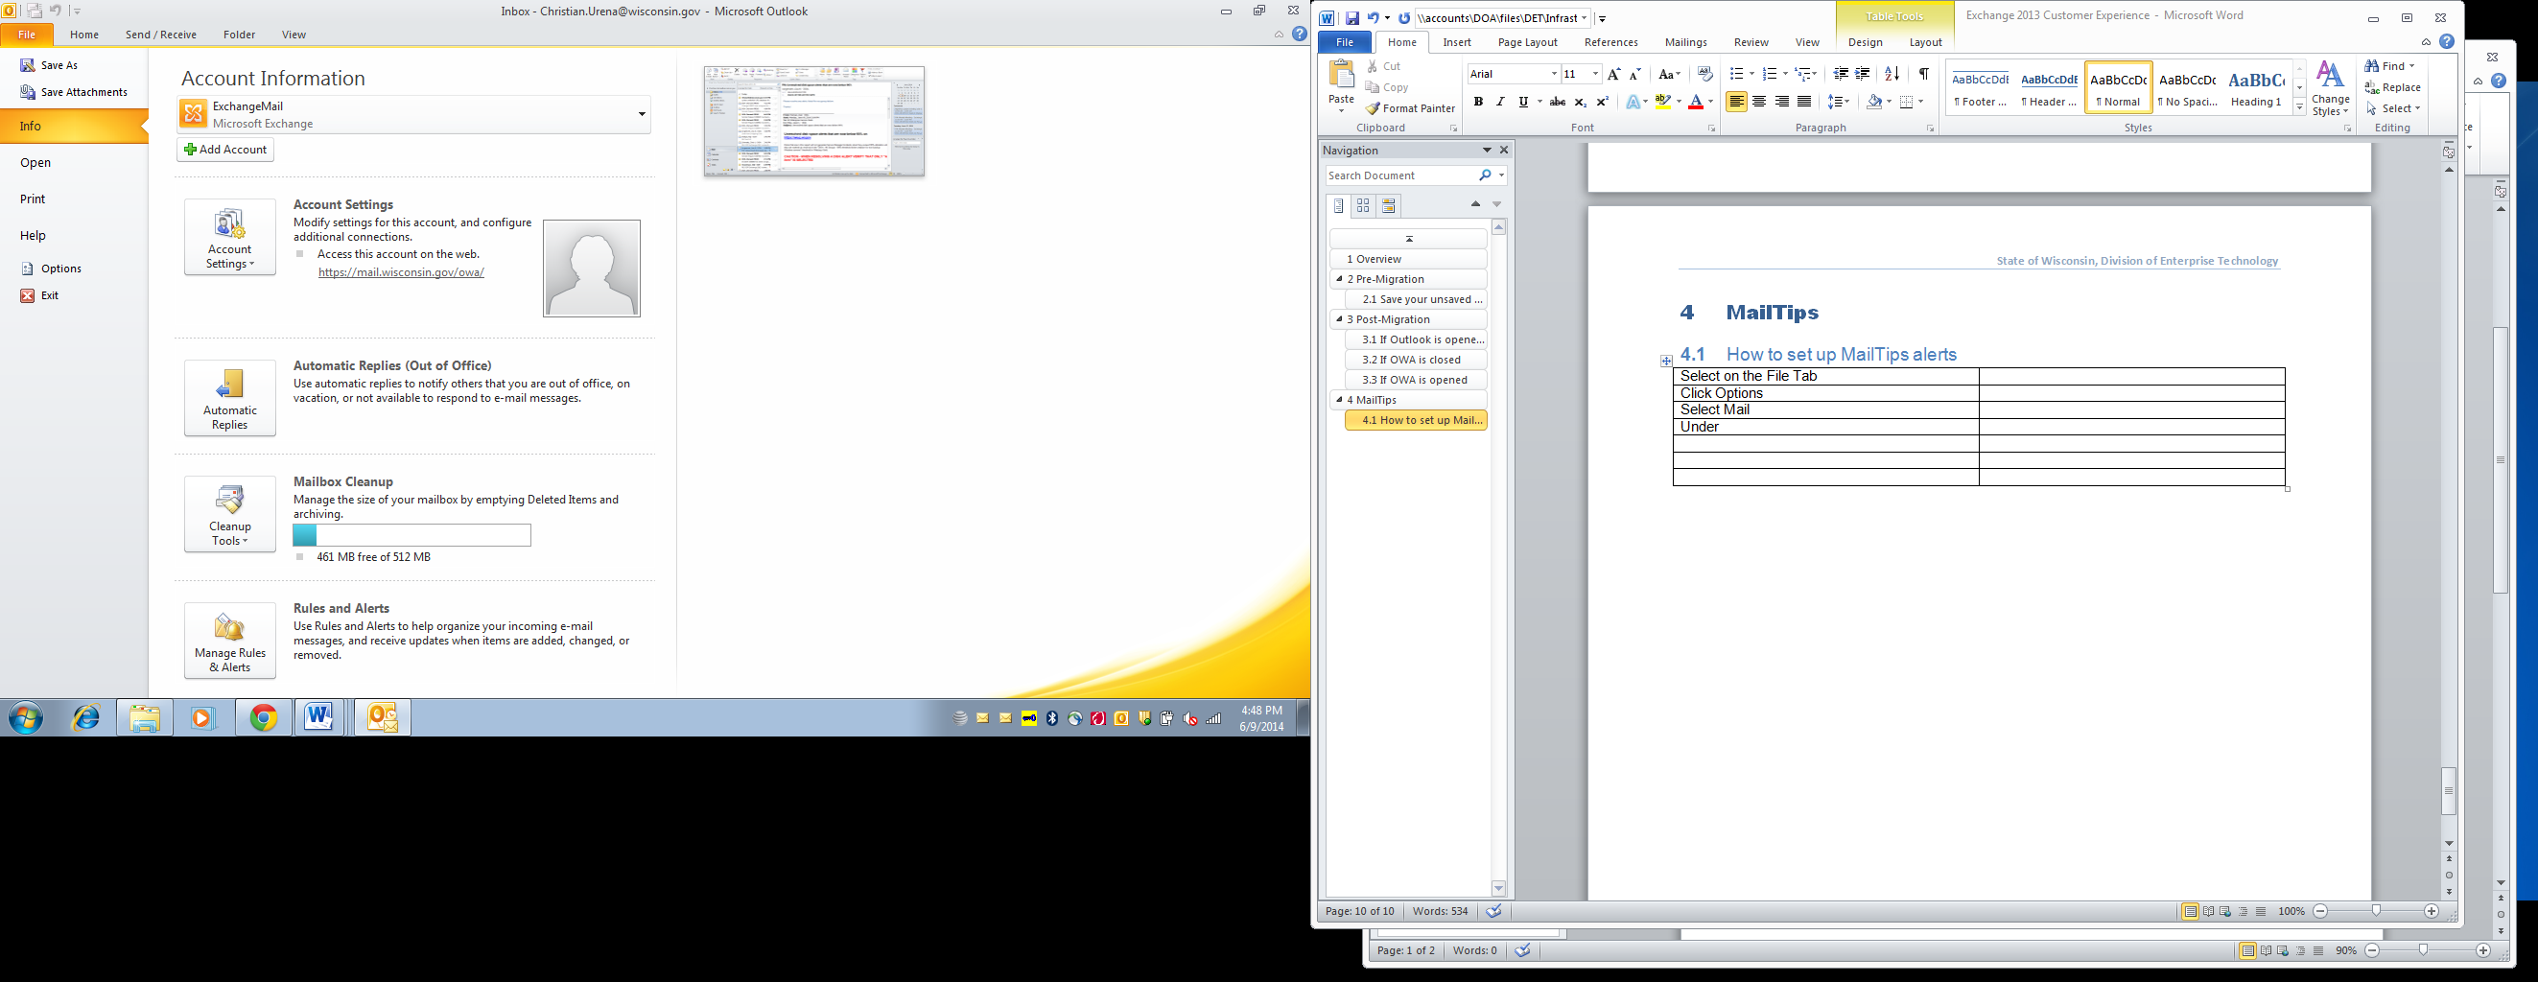

Select **Options** 

Select **Mail** 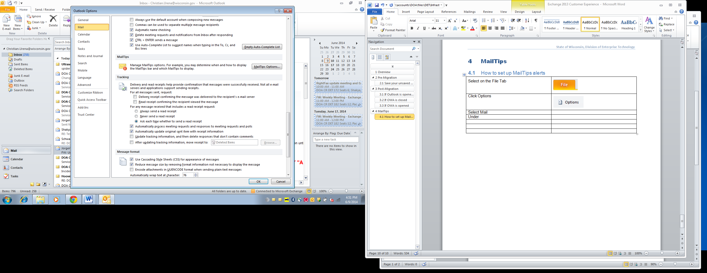

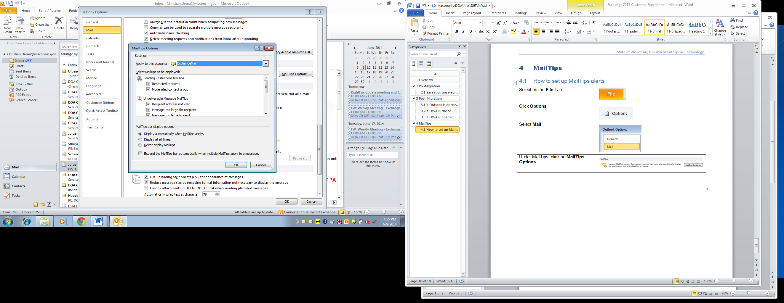Under **MailTips**, click the **MailTips Options…** button 

Under **MailTips Options**, select the options that you want and click **OK.**

|  |
| --- |
| F.2 Mailbox Quota Warning Messages |

When a mailbox reaches a set limit in size, a warning message is generated for the mailbox owner when they log in to the mailbox.

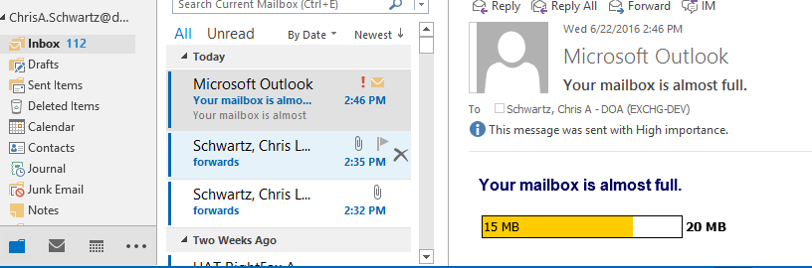

If a mailbox exceeds its mailbox limit after the owner has logged in, a message will be generated at the top of the Outlook screen.

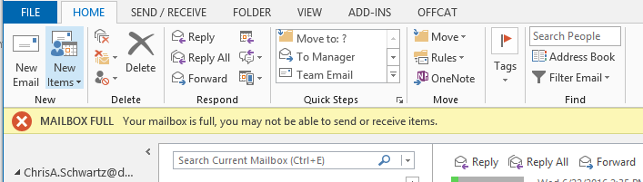

An administrator can see the current size of a mailbox by viewing the **mailbox usage** screen.

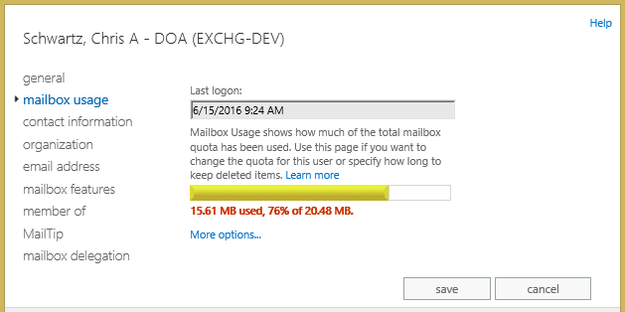

|  |
| --- |
| F.3 Open Distribution Groups |

Distribution Groups have configuration options to allow for self-service subscribing or unsubscribing, similar to a listserv list. When creating a Distribution Group administrators have options for how users get added to the group.

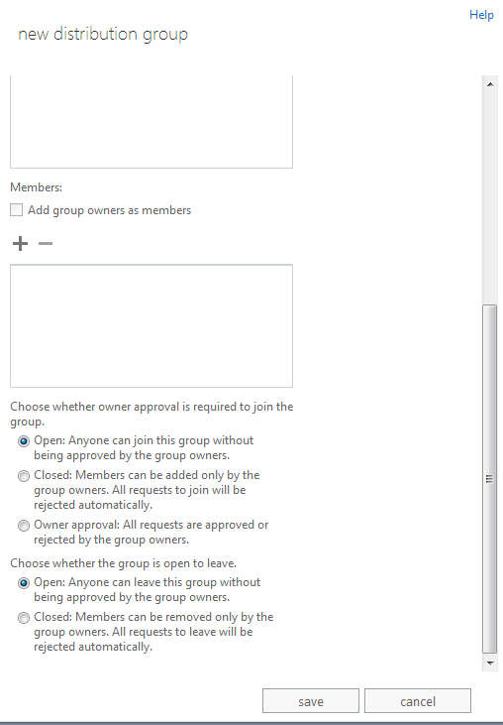

This feature is only supported in the Outlook Web Application (OWA). Users cannot subscribe to a list through the desktop Outlook client.

To view the distribution groups you are a member of and manage your membership options, log in to OWA.

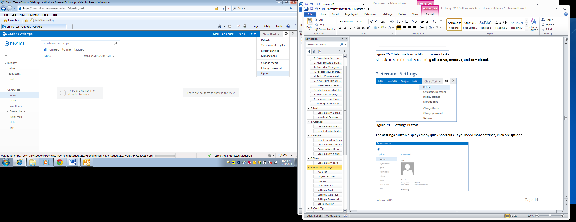Click on the gear icon located in the upper right corner of the OWA screen to launch Settings

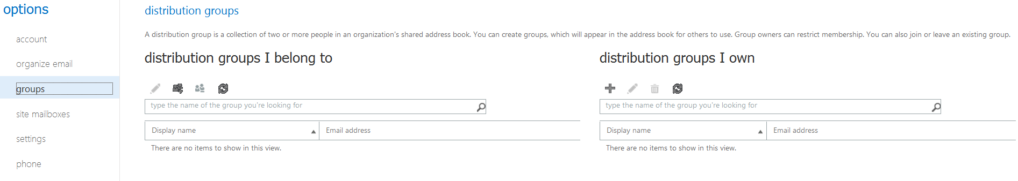

Select the **groups** tab in the left column.



Click on the **Join** icon.

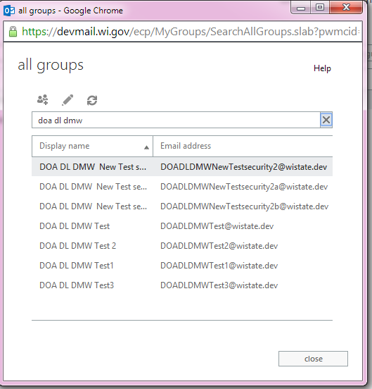

Search for the group you want to join, then click the **Join** icon again.

A notification will be displayed with the success or failure of your request to join that group.

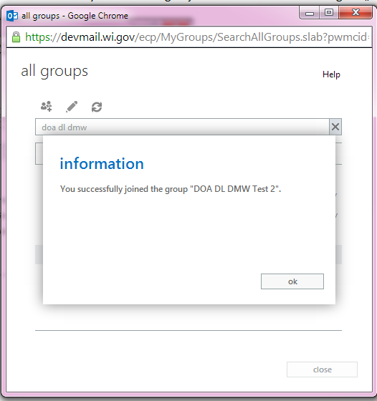 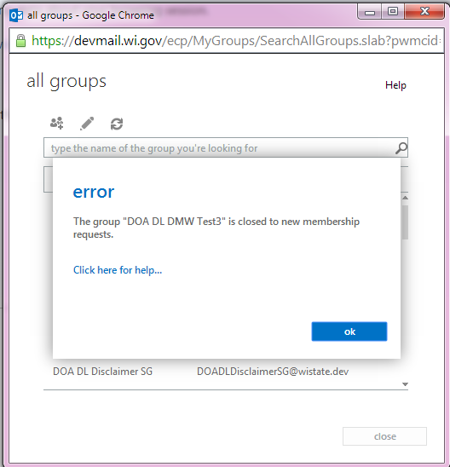

If a distribution group requires approval, a request will be submitted to the group owner/s.

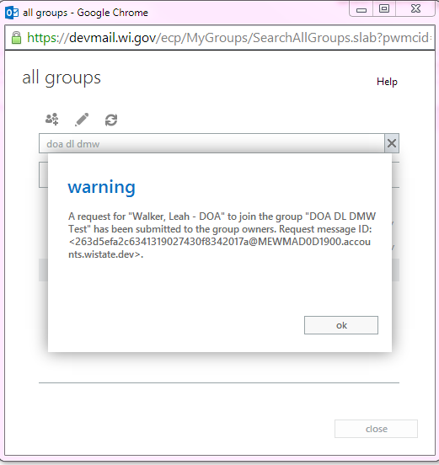

You will receive a message confirming if your request has been approved or rejected.

If approved

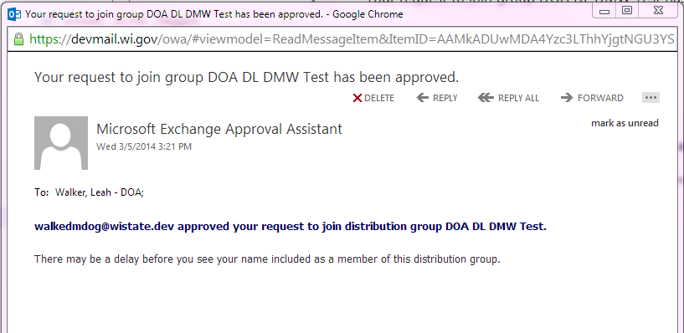

If rejected

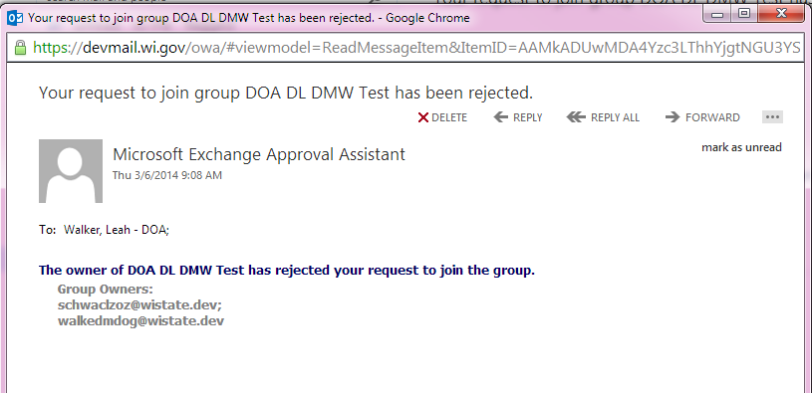

After successfully joining or approved, the new group will be displayed in the list of distribution groups to which you belong.

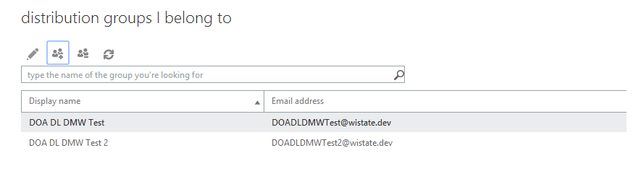

To return to the OWA Mail and Calendar screens, click the return arrow icon in the upper Left corner of the Options screen.

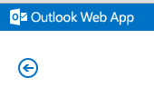

|  |
| --- |
| F.4 Mailbox Search and E-Discovery Options |

Agency Email Administrators and Security Officers who perform Email-related tasks have been delegated the permissions necessary to perform Mailbox searches and exports from mailboxes in their agency’s MailProv and Staff Organizational Units. Upon request, the person will be added to another delegation group called XXX_E-DiscoveryAdmin. This delegation group is designed to allow Agency Legal and investigative staff to perform Mailbox searches without having all of the elevated rights held by Email and Security Administrators.

Agency Email, Security, and E-Discovery Admins can:

* Perform full mailbox searches to return all content or specific items by using filters or keywords.
* Preview searches from within the ECP.
* Export search results to a .pst file.
* See the list of searches in the ECP and the search criteria, regardless of which agency initiated the search, but cannot access the search results for searches of mailboxes that are not within their scope.
* Configure Single-Item Recovery, In-Place Hold, and Litigation Hold on mailboxes within their scope.

Basic instructions for these functions are shown below. For more detailed information see the links to the Microsoft TechNet articles here.

[Search-Mailbox](http://technet.microsoft.com/en-us/library/dd298173(v=exchg.150).aspx)  
[Perform Single Item Recovery](http://technet.microsoft.com/en-us/library/ff660637(v=exchg.150).aspx)  
[Create an In-Place eDiscovery Search](http://technet.microsoft.com/en-us/library/dd353189(v=exchg.150).aspx)  
[Recoverable Items Folder](http://technet.microsoft.com/en-us/library/ee364755(v=exchg.150).aspx)

**How to perform a search using the ECP**

Log in to the ECP with your Administrative account. Click on **compliance management**, then click on **In‑place eDiscovery & hold**.

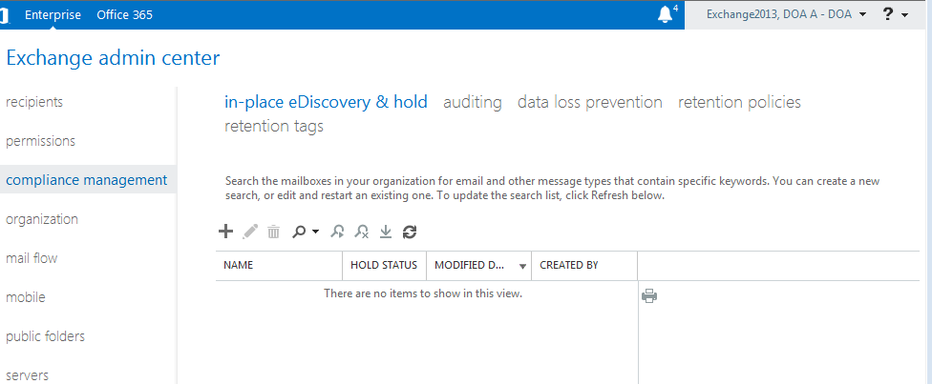

Click on the **+** to create a new search. Give the search a name and optionally a description. Click Next.

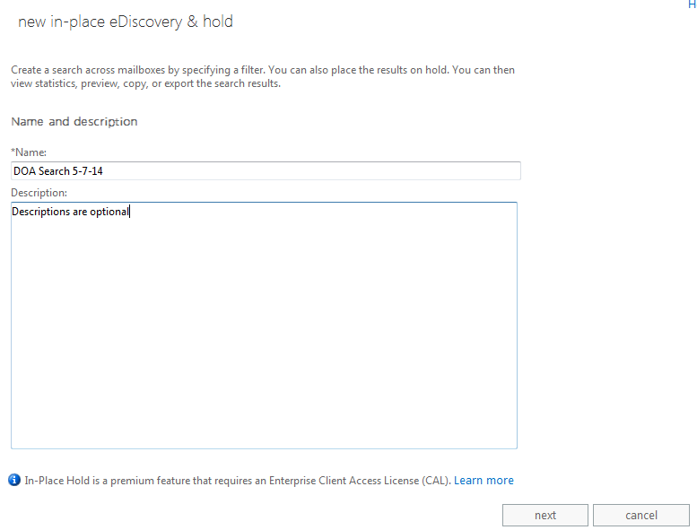

If searching in specific mailbox(es), click on the **+** to pick mailboxes from the GAL.

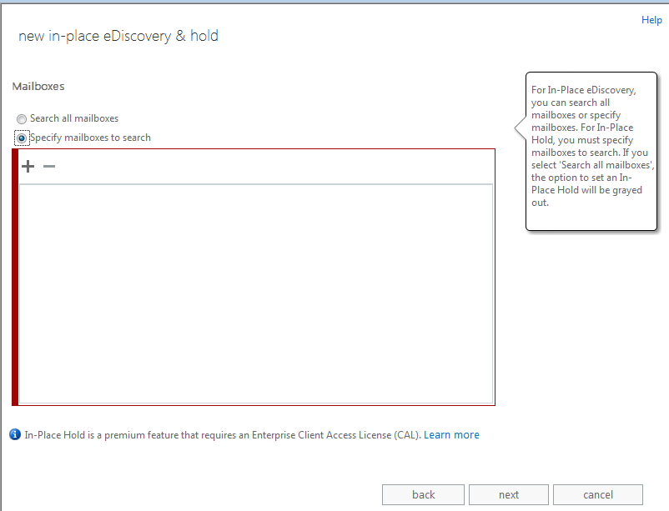

Select the appropriat account, double-click or click Add, then click Ok.

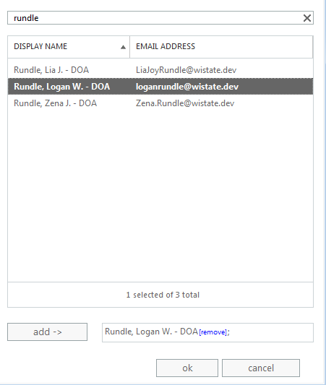

Click Next

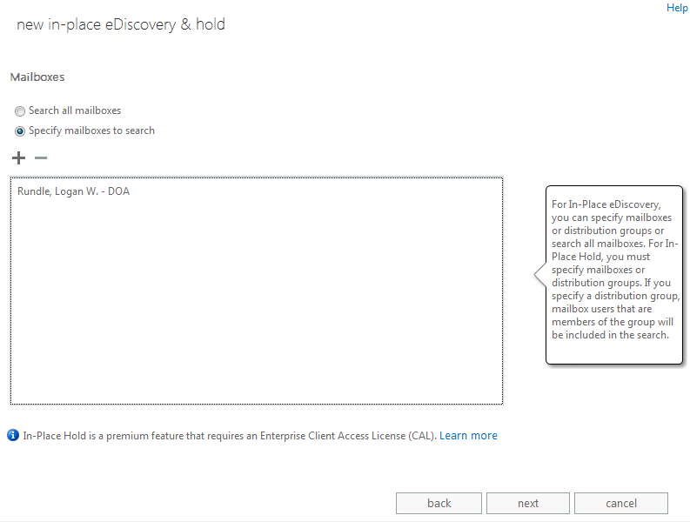

You can choose to search all user mailbox content or filter based on criteria.

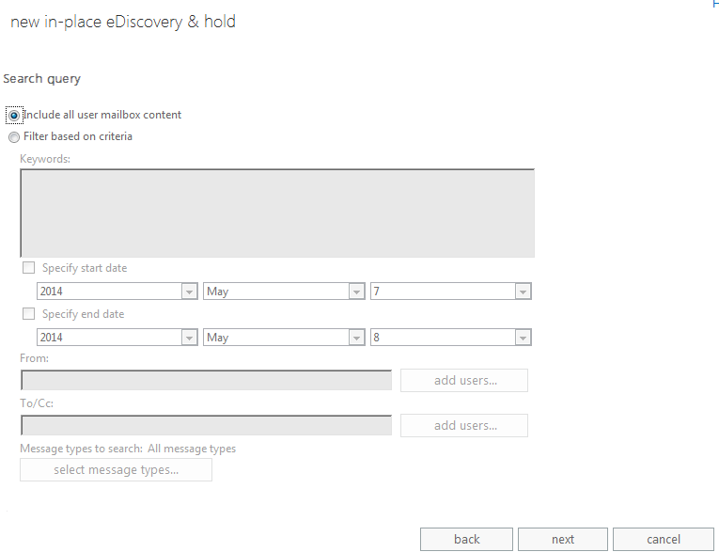

Click Finish on this page without making changes if you do not have an Enterprise Client Access License or if you selected ‘Search all mailboxes’ on the Mailboxes page.

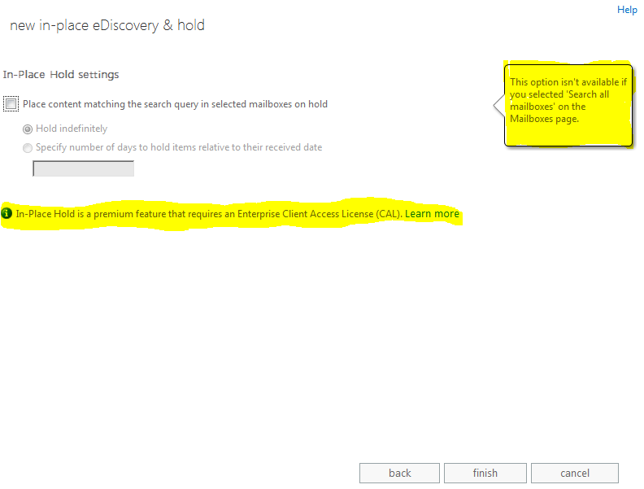

This step is validating the requestor’s delegated rights to complete a search on the mailbox(es) selected, and estimating the size of the search results.

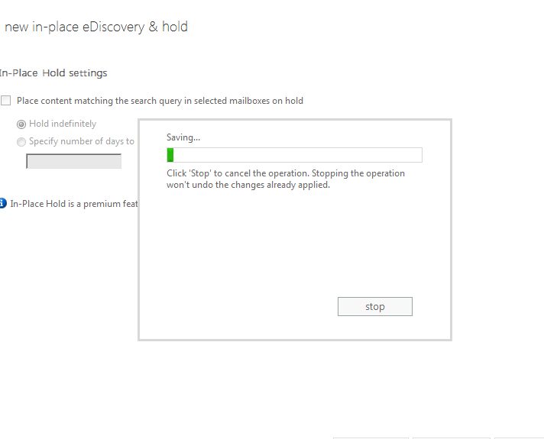

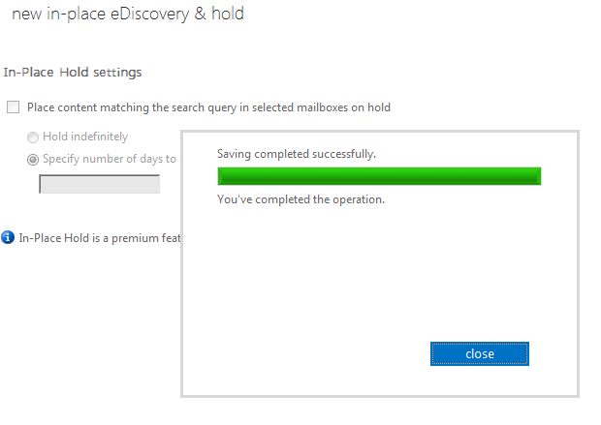

All searches created will be displayed in this screen until they are deleted. Since all delegated administrators can see the criteria of searches listed in this screen, it is **highly** recommended that you delete your search when it is no longer needed.

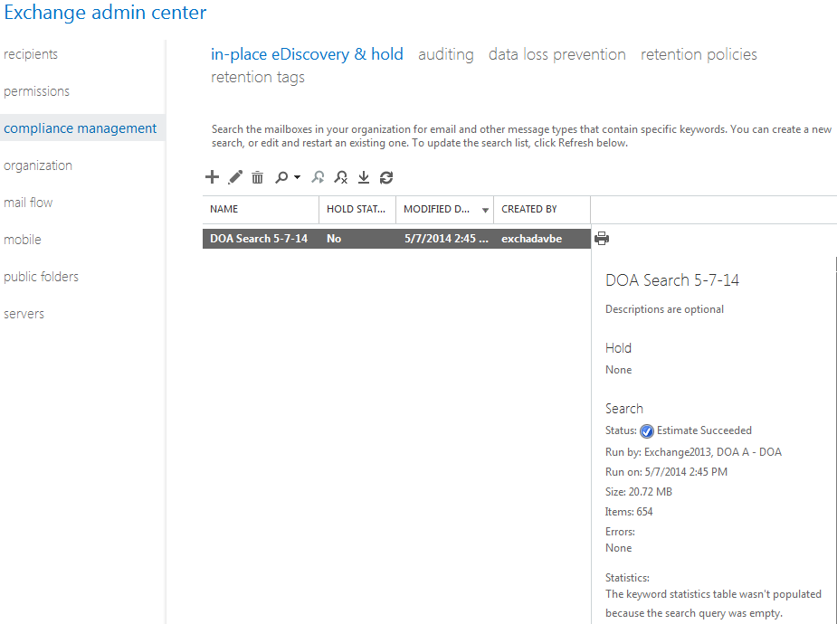

The icons provide functionality to work with your search. From left to right: New search, Edit search, Delete search, Search (see next screen), Resume search, Stop search, Export to a .pst, and refresh.

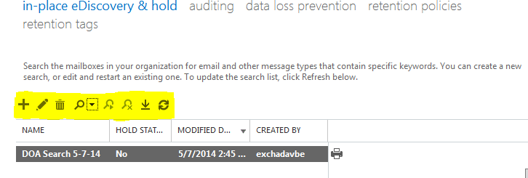

If you click on the **Search** icon dropdown immediately after the initial notice that the search estimate was successful, you will only be able to select Preview search results from this dropdown. When the search has completed you will be able to select the other options. **Preview search results** will show you a list of the items in the mailbox(es) but not the actual content. This is not particularly useful.

Selecting **Copy search results** will allow you to copy the search results to a Discovery mailbox so that you can view the actual content of items. In order to do this, your account must have access to a Discovery mailbox assigned to your agency otherwise the copy will fail.

Discovery mailboxes do not exist by default but you can request that DET create one for your agency.

**Note: Once a search is deleted from the list shown above, the search results that have been copied to a Discovery mailbox are purged, too.**

To keep the copy of the search results even after the search has been deleted, copy them from the Discovery Mailbox to another mailbox or use the **Export to .pst** option. Either option allows you to delete the search from the list without losing the results of the search.

