
e
Office 365 Agency Playbook

Prepared for
State of Wisconsin
9/20/2016
Version DraftDraftDraft

Initial Draft Prepared by
Steven Gemmel
Services Delivery Executive
steve.gemmel@microsoft.com
Contributors
DET Office 365 Production Prep Project Team

Revision and Signoff Sheet
Change Record
Date | Author | Version | Change Reference
5/16/2016 | Steve Gemmel | .1 | Initial draft for review/discussion
6/2/2016 | Steve Gemmel | .2 | 2nd Draft – New Processes
6/24/2016 | Ann Jakel Stormoen | .3 | DET edits
7/12/2016 | Ann Jakel Stormoen | .4 | Additional DET edits
7/21/2016 | Ann Jakel Stormoen | .5 | Additional DET edits
7/26/2016 | Ann Jakel Stormoen | .6 | Added document links
7/28/2016 | Ann Jakel Stormoen | .7 | Spelling and Grammar check; updated TOC
8/9/2016 | Ann Jakel Stormoen | .8 | Changes from Dave Meyer’s input
8/29/2016 | Ann Jakel Stormoen | .9 | Updates from pilot feedback
9/6/2016 | Ann Jakel Stormoen | 1.0 | Updates after final proofing

Reviewers
Date | Reviewer | Reference
7/29/2016 | Dave Meyer
8/29/2016 | Dave Meyer

Table of Contents
Definitions 7
Document Objective 9
Microsoft Office 365 Services 10
License Options 10
Exchange Plan 2 Only 10
E3 in Government Community Cloud 10
Enterprise Cloud Suite (ECS) Bundle 10
Ad-Hoc Non-Bundled Licenses 11
Purchasing Process 11
Assignment of Licenses 12
Overview of Technology 13
State ADFS Configuration 14
Tenant Configurations 14
State URL Monitoring 14
Tenant Configurations 14
State SharePoint Configuration 14
Tenant Configurations 14
Policy Decisions 14
What is not Included 14
State Exchange Configuration 15
Tenant Configurations 15
Policy Decisions 15
State OneDrive Configuration 15
Tenant Configurations 15
Policy Decisions 15
State Skype for Business Configuration 15
Tenant Configurations 15
Policy Decisions 15
Agency Workload Deployment Process Overview 15
Exchange Online Migration 15
Assessment Phase 16
Remediate 18
Enable 18
Migrate 18
Post Migration Activities 18
SharePoint Migration 19
Assess 19
The agency should review the State URL Monitoring 19
Tenant Configurations 19
Remediate 21
Enable 21
Migrate 21
SharePoint Greenfield Deployment 21
Assess 21
Remediate 22
Enable 22
OneDrive Migration (Personal File Share) Overview 23
Assess 23
Remediate 24
Enable 24
Migration 24
OneDrive Greenfield Deployment (No Migration) 25
Assess 25
Remediate 25
Enable 26
Skype for Business Deployment 26
Assess 26
Remediate 27
Enable 27
Office ProPlus for Office 365 Overview 28
Service Management 29
User Communications 29
Office 365 Support 29
Self Service 29
Agency Service Desk 29
DET Enterprise Service Desk 31
Microsoft Office 365 Included Support 32
Microsoft Premier Support 32
Change Management 33
Change Concepts 33
DET Office 365 Customer Advisory Group (CAG) 33
Resources 34
Compliance Management 37
User Audit Logs & Security Incident Event Management 38
Information Technology (IT) Security Policy Handbook 38
eDiscovery & Content Search 38
Litigation Hold, In-Place Hold, Retention Policies 38
Third Party Audit Reports 38
Data Loss Prevention 38
Managing the License Pool 38
Agency License Tracking 39
Agency License Monthly Report 39
Agency License Ad-Hoc Report 39
Purchasing Additional Licenses 39
User Provisioning/De-Provisioning 39
Provisioning Process 39
De-Provisioning Process 41
Disabling a User 41
Deleting a User 42
Removing a License from a user. (Create Inactive User) 42
Appendix 1: SEP (Service Enablement Plan) Network: Planning, Infrastructure, Configuration 44
Bandwidth Planning 44
Exchange Bandwidth Calculator 44
Skype for Business bandwidth calculator 44
SharePoint bandwidth 44
Network latency test tools 44
Ports, Protocols, IP(s) and URL(s) 45
IP Port requirements 45
Load Balancing 45
Port Exhaustion 45
Network Address Translation (NAT) 45
NAT limitations with Office 365 46
Calculating maximum supported devices behind a single public IP address /w Office 365 46
Mail Encryption, SSL “In Transit/Man in the middle” encryption and WAN accelerators 48
Inbound / Outbound Server Connections - AutoDiscover Service 48

Definitions
Active Directory Federated Services (ADFS) – Standards-based service for secure sharing of identity information between trusted business partners, in this case the State of Wisconsin’s Active Directory environment and Microsoft’s Office 365 Cloud environment. ADFS manages access control to State of Wisconsin Office 365 tenant.
Agency – For the purposes of this document, Agency refers to each of the State of Wisconsin departments, including the Department of Administration (DOA).
Agency Mail Administrator – Designation for Agency Administrators that have been trained and provided the ability to complete the following tasks for their subset of users.
- Create/Maintain/Configure/Delete Shared/Resource/Equipment mailboxes
- Grant Mailbox delegation
- Create/Maintain/Delete Mail Contacts
- Create/Maintain/Delete Distribution Groups
- Grant Distribution Group delegation
- Message tracking

Agency Security Administrator – Designation for Agency Administrators that have been trained and provided the ability to complete the following tasks for their subset of users.
- Enable/Disable Mailbox Features
- Grant Mailbox delegation
- Message tracking
- Compliance investigations

Claims Rules – Rules used by ADFS to specify the access that is granted to a user.
Enterprise Mobility Suite (EMS) – Solutions for managing security in the cloud. Microsoft’s EMS includes Azure AD premium (hybrid identity and access management, including multi-factor authentication), Intune (Mobile device and application management) and Azure Rights Management.
FastTrack Center (FTC) – A service from Microsoft that includes documentation, templates, tools, and services that can be used for an Office 365 rollout.
Flighting – Changes are deployed through a series of wider deployment rings
GCC – Microsoft Office 365 Government Community Cloud is a dedicated multi-tenant cloud-computing environment, physically separate from Microsoft’s Commercial Cloud environment.
Greenfield deployment – Installation and configuration of software where no current installation exists.
Mobile Device Management (MDM) – Tools to manage the administration of mobile devices.
Office 365 Admin Center – Office 365 Administration Portal.
Office 365 Exchange Online (EXO) – Exchange Services in the Microsoft Cloud. There are 3 service plans Exchange Plan 1, Exchange Plan 2 and Kiosk. Wisconsin is only supporting Exchange Plan 2 because it includes Enterprise Features such as Litigation Hold, DLP and Voicemail.
Office 365 SharePoint Online (SPO) – SharePoint & OneDrive Services in the Microsoft Cloud.
Office 365 Skype for Business Online (SfB) – Skype for Business (Formerly Lync) Service in the Microsoft Cloud.

Office ProPlus for Office 365 – A subscription to the Microsoft Office Suite. Each subscription provides access to 5 Desktops, 5 Tablets, and 5 Phones. This suite is deployed, maintained, and supported differently the previous Office Professional Plus Volume License though the end user applications are the same.
SHI – Software reseller through which the State of Wisconsin purchases Microsoft licensing.
Self Service Reset Password Management (SSRPM) – The account recovery tool used by users in the ACCOUNTS domain to recover/unlock accounts.
Service Enablement Plan (SEP) – Document produced by Microsoft outlining findings from Office 365 Assessment Workshop 2/22/16 and 2/23/16.
Service Administrator Role – This Office 365 role is used to grant Select Agency Administrators access to view the service dashboard and message center as well as opening and reading support tickets via the Office 365 Admin Portal.
SharePoint Portfolio Assessment - Microsoft led a four-to-six-week engagement to help you assess your current data and plan your move to SharePoint Online. A similar assessment can be performed without Microsoft’s assistance.
Tenant – Specific instance of a cloud service. This document refers to the State of Wisconsin enterprise tenant for Office 365.
T-minus – Counting down from the deployment date, T-minus refers to tasks on the project schedule that occur at set times before deployment.
UMRA – Software purchased from Tools 4 Ever that enables DET to delegate management of user accounts to Agencies through a custom interface. (e.g. Create AD Account w/ 500mb Mailbox)
Workload – The segmentation of administrative & licensing components of Office 365. Office 365 is broken into three primary workloads – Exchange Online, Skype for Business Online and SharePoint Online. OneDrive for Business is considered part of SharePoint Online.

Document Objective
This document has been created to provide an Agency Playbook for the Deployment of Office 365 within the State of Wisconsin.

Microsoft Office 365 Services
Microsoft provides a number of Office 365 licensing options to meet the needs of our broad customer base. While this provides flexibility, it can also create high levels of complexity when trying to manage licensing in large organizations. As a result, the following license options will be available to each state agency.

License Options

Exchange Plan 2 Only
This option is for Enterprises that only want to host email in the cloud.

E3 in Government Community Cloud
The E3 for Government (Also known as G3 or Government E3) Suite provides the full Office 365 Collaboration Suite including the Office Rich Client. It includes enterprise-required features such as In-Place Hold, Data Loss Prevention, Inactive Users and E-Discovery.
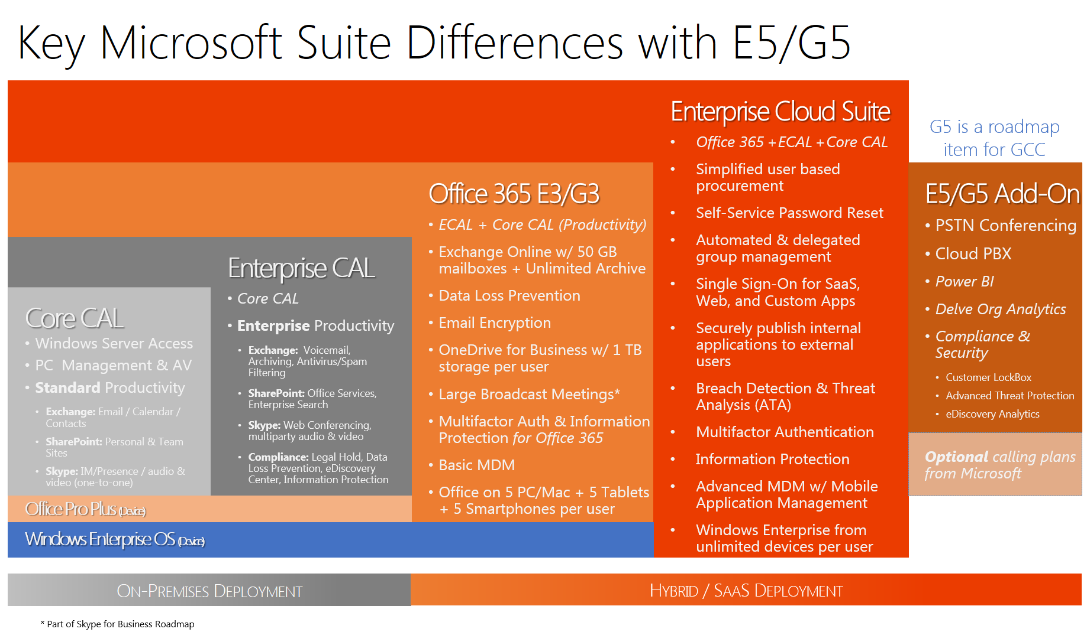

Enterprise Cloud Suite (ECS) Bundle
The Enterprise Cloud Suite bundles the security products from the Enterprise Mobility Suite (EMS) with the E3 license. ECS also provides on-prem licensing (e.g. Windows Enterprise) for cloud users. (See JoEllen Creager for more information.)
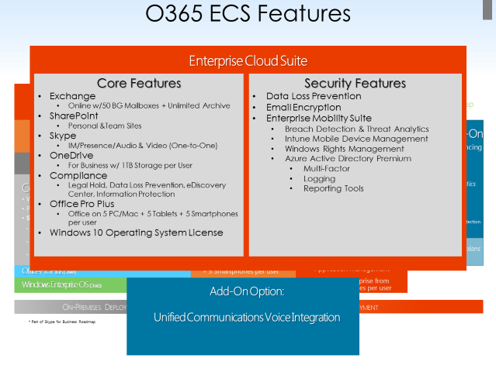

Ad-Hoc Non-Bundled Licenses
We expect to need to provide the ability to license ad-hoc applications such as Visio Pro for Office 365 and Project Pro for Office 365.

Purchasing Process
Each State Agency will continue to maintain their own Enterprise Agreement with Microsoft and be responsible for maintaining the correct number of licenses for their agency.

Sign Enterprise Agreement (EA) - DOA signs along with the agency’s committed enrollment

Software reseller (usually SHI) processes purchase

Agency receives activation email

Agency submits a Cherwell Support Ticket attaching the Activation Email to the Ticket

DET applies licenses to State Tenant

Ticket closed

Each agency manages their license counts and subscriptions through “License Reservation” for annual true up/down

Agency pays their software reseller annually for the new enrollment and annual true-ups

Annual agency enrollment includes covering “License Reservations” during the year and annual enrollment costs.

Agency annual enrollment/renewal continue on the current schedule

Assignment of Licenses
The person who has initiated the financial transaction will receive the activation email from Microsoft, inviting him/her to associate obtained licenses to the tenant of his/her choice.
This email will provide a link to either create a new tenant or add licenses to an existing Tenant. (Do not click any activation links in this email.) This email should be attached to a Cherwell Support Ticket and sent to DET to apply the license to the state tenant. DET will then open the link while signed in as a Global Administrator applying the Agencies license to the License pool.
Microsoft has observed cases when licenses are attached/associated with a wrong tenant, when a recipient logs-in to another tenant or accidently creates a new tenant. De-associating licenses from one tenant and re-assigning them to the correct production tenant is time consuming and difficult. Therefore, avoid accidental license assignment to the wrong tenant and carefully track the invitation email. Do not use an in-private IE session when accepting and attaching licenses. Also, ensure that no other tenants’ credentials are used during login.
Figure 1: Activation Email - Do not click any activation links in this email. Attach it to a Cherwell Support Ticket and sent to DET to apply the license to the state tenant.
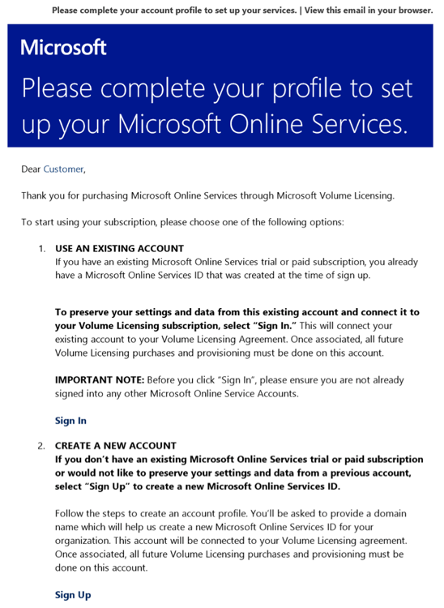

Overview of Technology
O365 Architecture

State ADFS Configuration

Tenant Configurations
The Federated ADFS Farm is fs2.wisconsin.gov. This farm is configured for Forms Authentication on the Extranet and Windows Integrated Authentication on the Internal. Agencies that have migrated their users & workstations to the accounts domain can take advantage of Windows Integrated Authentication allowing pass through authentication. For Office 365 ProPlus and for Office 365 portal single sign on, agencies will need to add the ADFS server farm to their Local Intranet Zone.
Agencies that have users logging into systems that are joined to Agency AD Domains and are forcing Windows Authentication via group policy can leverage forms authentication by following this process.
If DET is managing your internal DNS, please open a Cherwell service request for the work. If you are managing your DNS, create a new zone for fs2.wisconsin.gov and point the A record to 165.189.157.100.

State URL Monitoring

Tenant Configurations
DOA and several other Agencies use Zscaler as a network security / content filtering solution. DET has done extensive configuration and testing to verify full compatibility of Zscaler with Office 365 including Skype for Business. Use of a network security / content filtering system other than Zscaler will require additional configuration and testing. This effort will be the responsibility of any Agency using a solution other than Zscaler and should be identified as a risk to the timeline of the Agency’s Office 365 deployment.

State SharePoint Configuration

Tenant Configurations
- External Sharing can be enabled or disabled at the SharePoint Site Collection level.
- Access Apps are enabled.
- Cortana has been disabled.
- SharePoint Hybrid has not been deployed.
- User Profile Pictures have been disabled

Policy Decisions
- Policies on external sharing are the responsibility of the agencies.
- User Profile Pictures will not be used.

What is not Included
- Migration Services. This includes any tools that need to be purchased for SharePoint migration from the Enterprise SharePoint environment to SharePoint Online as well as any Microsoft professional services that might be required to perform the migration.
- Add on Software. Agencies will be responsible for paying for the licensing required for any subscriptions for add-on software that is not enterprise-wide or is priced such that one agency would need more than another agency. The reason each agency will be responsible for this software add-on is because each agency has very different needs and some agencies will not utilize Nintex Forms or Work Flows at all.
Nintex Forms and Workflow subscriptions will be procured by DET based on agency-identified need and billed back to each agency. One type of add-on software that will be included in the service is the software required for Item Level backups. This will not be charged back to the agencies, but rather bundled into the O365 subscription fee. Any additional software add-on requests will be handled on a case-by-case basis.
Agencies should test all existing add-on software they are using with Office ProPlus. Some add-on software may require updating to work with a newer release of Office.
State Exchange Configuration

Tenant Configurations
- Internal & External mail will be routed through On-Prem IronPort Devices

Policy Decisions
- Agencies will not be able to create their own Distribution Lists. The agency should submit a Service Request to create a new DL. Once created, the agency will be responsible for maintaining and deleting the DL.

State OneDrive Configuration

Tenant Configurations
- Due to limited use of OneDrive during initial rollout, the configuration of OneDrive to be reviewed at a later date.

Policy Decisions
- Synchronizing OneDrive data to personal devices not owned by the State has been disabled.

State Skype for Business Configuration

Tenant Configurations
- Conversation Archiving to the Exchange Mailbox ‘Conversation History’ folder is on by default.

Policy Decisions
- Skype for Business conversations should follow State Records policy and the appropriate RDA (Records Retention/Disposition Authorization.

Agency Workload Deployment Process Overview
Each Office 365 Workload has a separate migration process, which is detailed below.

Exchange Online Migration
Agency IT managers and technicians should expect Exchange Online migrations to be very similar to migrating to a new version of Exchange On-premise. Exchange Online is simply an extension of the state’s Exchange platform and leverages the built in migration tools.

Assessment Phase
This phase is dedicated to assessing the agencies environment and identifying any dependencies that need to be remediated before enabling the Office 365 Service. Since agencies are consuming a service provided by DET, these dependencies are expected to be around client, network and process readiness.

Review Microsoft Office 365 Service Description
https://technet.microsoft.com/en-us/library/office-365-service-descriptions.aspx

Review Exchange Services in Use
The agency should review any Exchange functionality currently in use by the agency. This may include Shared Mailboxes, Public Folders, Archive Mailboxes, eDiscovery, Archiving Solutions, PSTs, OWA Policies, ActiveSync Policies, Retention Polices, Hold Policies, etc.
Shared Mailboxes: Agencies need to determine if they require e-discovery and litigation hold capabilities for their shared mailboxes. If so, they will need to purchase an Exchange Only license for those Shared Mailboxes that require those features. Also any shared mailboxes that need to be logged into will require the same license.

Review Use of Distribution Lists
Applications and SharePoint sites that utilize Exchange Security Enabled Distribution Lists (DL) as a Security Group will not work properly after the DL is migrated to Office 365. Any rights that have been granted within the application or SharePoint using this method will need to be modified before the DL’s are migrated to Office 365 to use another option.
The agency should review Distribution Lists and Security Groups to determine when to migrate each. A Distribution List or Security Group that is on premise cannot be maintained by a user whose Exchange mailbox has been migrated. Likewise, a Distribution List or Security Group that is Online cannot be maintained by a user whose Exchange mailbox is on premise. If Security Groups are used to set permissions for viewing Free/Busy information or folder access permissions are lost when the mailbox is migrated and reset, users will need to reset permissions for the migrated Security Group.

These links provide additional information for troubleshooting Free/Busy issues: https://testconnectivity.microsoft.com/
https://support.microsoft.com/en-us/help/10092/troubleshooting-free-busy-issues-in-exchange-hybrid-environment

Review Handling of Clutter/Junk Mail
Exchange OnLine has built-in handling of clutter and junk mail that differs slightly from previous versions of Exchange. Review the information in this link to learn more: https://support.office.com/en-us/article/Use-Clutter-to-sort-low-priority-messages-in-Outlook-7b50c5db-7704-4e55-8a1b-dfc7bf1eafa0
https://support.office.com/en-us/article/Block-or-allow-junk-email-settings-48c9f6f7-2309-4f95-9a4d-de987e880e46?ui=en-US&rs=en-US&ad=US

Review DET Exchange SOD and Roles & Responsibilities Documentation
O365 Exchange Online SOD
Exchange Online Roles and Responsibilities

Review DET Email Administrator Guide
E-Mail Admin Guide to Exchange 2013 and Exchange OnLine

Review DET Agency T-Minus Process
Office 365 Agency T-Minus Action Items (05-5-2016) Template

Review DET Workflow Process for Mailbox Migration
Managing Mailbox Migration Workflow Diagram
Managing Mailbox Migration Workflow Narrative

Review Client Readiness Requirements
Agencies must ensure that their clients (Desktops/Tablets/Phones) meet the minimum system requirements located here: https://products.office.com/en-US/office-system-requirements/#Office365forBEG. In addition to client readiness, agencies should be aware Microsoft highly recommends Outlook be configured for cached mode rather than online mode for the best performance.

Client Authentication
Agencies that have migrated their users & workstations to the accounts domain can take advantage of Windows Integrated Authentication allowing pass through authentication. Agencies will need to add the ADFS server to their Local Intranet Zone.

Review Network Readiness Requirements
Wisconsin DOA supports a statewide network. Most agencies leverage this for Internet access. There are some remote sites that have bandwidth as low as a 1.5MBPS. These sites will have to be assessed and possibly upgraded to a higher bandwidth network in order to support the O365 workloads. There are certain agencies that also control their own firewalls and proxies. Care must be taken to ensure that all O365 URLs are “white listed” and the sufficient external IP addresses are available to avoid port exhaustion (this includes internal firewalls).
These items are outlined in Appendix 1: SEP (Service Enablement Plan) Network: Planning, Infrastructure, Configuration

Review Mobile Device Management
Most phones & tablets will require reconfiguration to work with Office 365 after the mailbox is migrated. Agencies will need to work on a reconfiguration plan with DET or the vendor or internal group that provides support to the Agency for mobile devices.

Enable Service Administrators
DET will assign select Agency administrators to the Service Administrator Role. The role provides read-only access to the Office 365 Admin Portal.

Remediate
In this phase, any items identified in the Assessment phase as requiring remediation should be resolved.

Enable
This phase is dedicated to configuring and testing the service.

Assign Licenses to State of Wisconsin Tenant
Assignment of Licenses User Licensing Final Workflow Workflow Diagram User Licensing Final Documentation Workflow Narrative

Verify Domain Ownership
Confirm that DET has completed the following:
- Add and verify the domain name with Office 365 Service.
- Create the DNS records that are required to route domain traffic to Office 365 Service
Note: Domain/Namespace verification is a onetime operation.

Migration of Pilot Users
Execute pilot migration per Exchange migration plan developed jointly by DET and the agency. Agency should also develop test plan for pilot users and E-mail admins to ensure all functionality is working as expected per agency business requirements.

Prepare Migration Communications
Prepare the T-Minus Communications. A sample template can be found here: O365-SOWI-Communication-Plan

Migrate
Execute migration per Exchange migration plan developed jointly by DET and the agency.

Post Migration Activities

PST Migration
Agencies may choose to migrate user PST files into Exchange Online to make them available for eDiscovery. This migration will need to be coordinated with DET using the built-in the PST Network/Drive Shipping solution built into Office 365. There may be additional cost associated with this. https://technet.microsoft.com/en-us/library/ms.o365.cc.ingestionhelp.aspx

Archiving Solutions
Agencies may desire to migrate third party on premise archiving solutions into Exchange Online. Third Party products can either migrate archives into PSTs for uploading into Exchange Online or provide direct migration of content to Exchange Online. This would be a coordinated effort between the requesting agency, DET and Microsoft and will incur consulting charges from DET and possibly require professional services from Microsoft. All costs would be the responsibility of the requesting agency.

SharePoint Migration
SharePoint migrations will be Agency-led initiatives that will require relatively little DET involvement compared to Exchange & Skype for Business. With SharePoint, while Microsoft and DET provide the base platform, for the most part, the content, structure, usage, governance and support are all controlled at the agency level.

SharePoint Migrations are the most complex of any of the workloads because the content and usage of the SharePoint platform will vary from customer to customer. As a result, each migration requires an assessment or inventory of content to develop a plan for migration. Some agencies may decide to not migrate existing SharePoint sites. In addition, Microsoft does not provide a migration tool for SharePoint Online but instead each agency must purchase a third Party Migration Tool.

Assess

Review Microsoft Office 365 Service Description
https://technet.microsoft.com/en-us/library/office-365-service-descriptions.aspx

Review DET Technology Decisions

The agency should review the State URL Monitoring

Tenant Configurations
DOA and several other Agencies use Zscaler as a network security / content filtering solution. DET has done extensive configuration and testing to verify full compatibility of Zscaler with Office 365 including Skype for Business. Use of a network security / content filtering system other than Zscaler will require additional configuration and testing. This effort will be the responsibility of any Agency using a solution other than Zscaler and should be identified as a risk to the timeline of the Agency’s Office 365 deployment.

State SharePoint Configuration included above and ensure a complete understanding of the deployment model used for the Central Tenant.

Review DET SharePoint SOD and Roles & Responsibilities Documentation
SharePoint - O365 Roles and Responsibilities
O365 SharePoint Online SOD

Client Authentication
Agencies that have migrated their users & workstations to the accounts domain can take advantage of Windows Integrated Authentication allowing pass through authentication. Agencies will need to add the ADFS server to their Local Intranet Zone.

Review Client Readiness Requirements
Agencies must ensure that their clients (Desktops/Tablets/Phones) meet the minimum system requirements located here: https://products.office.com/en-US/office-system-requirements/#Office365forBEG

Review Network Readiness Requirements
Wisconsin DOA supports a statewide network. Most agencies leverage this for Internet access. There are some remote sites that have bandwidth as low as a 1.5MBPS. These sites will have to be assessed and possibly upgraded to a higher bandwidth network in order to support the O365 workloads. There are certain agencies that also control their own firewalls and proxies. Care must be taken to ensure that all O365 URLs are “white listed” and the sufficient external IP addresses are available to avoid port exhaustion (this includes internal firewalls).
These items are outlined in Appendix 1: SEP (Service Enablement Plan) Network: Planning, Infrastructure, Configuration

Enable Service Administrators
DET will assign select agency administrators to the Service Administrator Role. The role provides read-only access to the Office 365 Admin Portal. Agencies should identify to whom they would like to have this role assigned when they initiate their migration to any Office 365 services.

Assessment of SharePoint Content
Each agency should complete a SharePoint Portfolio Assessment Analysis of their existing SharePoint environment. The analysis should provide directives and remediation actions to complete, in preparation for the enablement and migration phases.

Assessment of SharePoint Custom Code
SharePoint can be used as a development platform. If you are running custom code, you will need to identify if that code is compatible with SharePoint Online. A SharePoint Portfolio Assessment will provide you with guidance on how to remediate your codebase to be compatible with SPO.

SharePoint Governance Review
During your Migration to SharePoint Online, it is recommended that you review your SharePoint Governance Plan. Long deployed SharePoint implementations may have a governance model that is outdated.

3rd Party Migration Tool Selection
You will need to procure a SharePoint Migration tool which you will use for the migration. Since Agencies maintain Site Collection Admin rights both on-prem and in the cloud, the migration can be completely managed by the agency.

Develop Migration Plan
Create a migration plan for moving on-prem content into SharePoint Online. This migration plan should be the outcome of your SharePoint Content Assessments, SharePoint Custom Code Review, SharePoint Governance Plan and Migration Tool Selection.

Remediate
Complete remediation items from the Content Assessment and Custom Code Assessment. This may include deletion of content, revising site structure, or developing a migration strategy for content that cannot migrate. Custom Code may need revised and non-compatible third Party products may need retired.

Enable

Assign Licenses to State of Wisconsin Tenant
Assignment of Licenses User Licensing Final Workflow Workflow Diagram User Licensing Final Documentation Workflow Narrative

Provision Initial Site Collection(s)
Submit request to DET for Site Collection Provisioning and to assign Agency Staff as Site Collection Administrators.

Configure SharePoint per Agency Governance & Migration Plan
Agencies should configure SharePoint per their governance and migration plan. Agencies may need to work with DET on centrally controlled features such as the Video & Content Type Hub.

License Agency Users for SharePoint Access
Agencies submit a Service Request to assign SharePoint Online License for User access. DET activates the license.

Test 3rd Party Migration Tools
Implement and test 3rd party migration tools with agency content. Begin developing migration scripts within the toolset.

Complete Pilot Migrations
Complete Pilot Migrations of SharePoint Content using the migration tool.

Migrate
Execute Migration Plan developed during the assessment phase of the project. These migrations are the responsibility of the Agency; however, they should ensure close coordination to ensure migrations do not impact other Agencies using shared DET Networks/SharePoint Farms.

SharePoint Greenfield Deployment
A greenfield deployment assumes that the agency does not plan to migrate any existing SharePoint content to SharePoint Online.

Assess
This phase is dedicated to assessing the agencies environment and identifying any dependencies that need to be remediated before enabling the Office 365 Service.

Review Microsoft Office 365 Service Description
https://technet.microsoft.com/en-us/library/office-365-service-descriptions.aspx

Review State SharePoint Configuration
The agency should review the technology overview included above and ensure a complete understanding of the deployment model used for the Central Tenant.

Review DET SharePoint Roles & Responsibilities Documentation
SharePoint - O365 Roles and Responsibilities
O365 SharePoint Online SOD

Review Client Readiness Requirements
Agencies must ensure that their clients (Desktops/Tablets/Phones) meet the minimum system requirements located here: https://products.office.com/en-US/office-system-requirements/#Office365forBEG

Client Authentication
Agencies that have migrated their users & workstations to the accounts domain can take advantage of Windows Integrated Authentication allowing pass through authentication. Agencies will need to add the ADFS server fs2.wisconsin.gov to their Local Intranet Zone.

Review Network Readiness Requirements
Wisconsin DOA supports a statewide network. Most agencies leverage this for Internet access. There are some remote sites that have bandwidth as low as a 1.5MBPS. These sites will have to be assessed and possibly upgraded to a higher bandwidth network in order to support the O365 workloads. There are certain agencies that also control their own firewalls and proxies. Care must be taken to ensure that all O365 URLs are “white listed” and the sufficient external IP addresses are available to avoid port exhaustion (this includes internal firewalls).
These items are outlined in Appendix 1: SEP (Service Enablement Plan) Network: Planning, Infrastructure, Configuration

Enable Service Administrators
DET will assign select agency administrators to the Service Administrator Role. The role provides read-only access to the Office 365 Admin Portal.

SharePoint Governance
Microsoft recommends developing a strong Agency Governance plan for SharePoint Online prior to the technical deployment. This governance plan should lay out the usage plan, information architecture and support model for deployment.

Remediate
In this phase, any items identified in the Assessment phase as requiring remediation should be resolved.

Enable
This phase is dedicated to configuring and testing the service.

Assign Licenses to State of Wisconsin Tenant
Assignment of Licenses User Licensing Final Workflow Workflow Diagram User Licensing Final Documentation Workflow Narrative

Provision Initial Site Collection
Submit request to DET for Site Collection Provisioning and enable Agency Staff as Site Collection Administrators.

Configure SharePoint according to the Agencies Governance Plan
Agencies should configure SharePoint per their governance plan. Agencies may need to work with DET on centrally controlled features such as the Office 365 Video Portal & Content Type Hub.

License Agency Users for SharePoint Access
Agencies submit a Service Request to assign SharePoint Online License for User access. DET activates the license.

OneDrive Migration (Personal File Share) Overview
OneDrive is purchased, licensed and built on SharePoint technologies. However, migrations to OneDrive are considered part of the Enterprise File Sync and Share (EFSS) initiatives as organizations migrate from Personal File Shares into OneDrive for Business.

Assess

Review Microsoft Office 365 Service Description
https://technet.microsoft.com/en-us/library/office-365-service-descriptions.aspx

Analyze Content
All content that is to be migrated will need to be scanned for invalid characters, filename length, and size limitations. Tools & Guidance are included as part of Microsoft’s Fast Track Center (FTC).

Plan for Sync Client Deployment
Microsoft provides a Sync Client that enables desktop integration with Windows Explorer and Office ProPlus for Office 365. Agencies should consider bandwidth constraints when deploying the Sync Client. See information here on Sync Client. https://support.office.com/en-us/article/Deploying-the-OneDrive-for-Business-Next-Generation-Sync-Client-in-an-enterprise-environment-3f3a511c-30c6-404a-98bf-76f95c519668?ui=en-US&rs=en-US&ad=US

Client Authentication
Agencies that have migrated their users & workstations to the accounts domain can take advantage of Windows Integrated Authentication allowing pass through authentication. Agencies will need to add the ADFS server to their Local Intranet Zone.

Review Client Readiness Requirements
Agencies must ensure that their clients (Desktops/Tablets/Phones) meet the minimum system requirements located here: https://products.office.com/en-US/office-system-requirements/#Office365forBEG

Review Network Readiness Requirements
Wisconsin DOA supports a statewide network. Most agencies leverage this for Internet access. There are some remote sites that have bandwidth as low as a 1.5MBPS. These sites will have to be assessed and possibly upgraded to a higher bandwidth network in order to support the O365 workloads. There are certain agencies that also control their own firewalls and proxies. Care must be taken to ensure that all O365 URLs are “white listed” and the sufficient external IP addresses are available to avoid port exhaustion (this includes internal firewalls).
These items are outlined in Appendix 1: SEP (Service Enablement Plan) Network: Planning, Infrastructure, Configuration

Review Mobile Device Management
Agencies may want to plan to deploy the Office 365 OneDrive client to Phones/Tablets. The Agency’s Office 365 Migration project team will need to develop a deployment plan with DET or the vendor or internal group that provides support to the Agency for MDM.

Remediate

Remediate Incompatibilities in Data
Agencies will need to remediate all files identified as incompatible with OneDrive. The Microsoft FastTrack Center (FTC) can provide tools to automate remediation.

Enable

Pilot Sync Client to Desktops
Agencies will need to pilot the deployment of OneDrive Sync Client to their desktops using their desktop management tool of choice.

Pilot Mobile App
Agencies will need to pilot the deployment of the OneDrive app to their user’s mobile devices.

Pilot Migrations
Agencies will work with DET to pilot migrations.

Migration

Deploy Sync Client to Desktops
Agencies will deploy OneDrive Sync Client to desktops using their desktop management tool of choice.

Deploy Mobile App
Agencies will need to deploy the OneDrive app to their user’s mobile devices.

User Communications
Agencies will want to communicate to their staff the purpose and expected usage for OneDrive for Business.

Schedule Migrations
Agencies will submit a service request to work with DET to migrate content.

OneDrive Greenfield Deployment (No Migration)
OneDrive is purchased, licensed, and built on SharePoint technologies. A greenfield deployment assumes that any data migration will be the responsibility of the end user.

Assess

Review Microsoft Office 365 Service Description
https://technet.microsoft.com/en-us/library/office-365-service-descriptions.aspx

Plan for Sync Client Deployment
Microsoft provides a Sync Client that enables desktop integration with Windows Explorer and Office ProPlus for Office 365. Agencies should consider bandwidth constraints when deploying the Sync Client. See information here on Sync Client. https://support.office.com/en-us/article/Deploying-the-OneDrive-for-Business-Next-Generation-Sync-Client-in-an-enterprise-environment-3f3a511c-30c6-404a-98bf-76f95c519668?ui=en-US&rs=en-US&ad=US

Client Authentication
Agencies that have migrated their users & workstations to the accounts domain can take advantage of Windows Integrated Authentication allowing pass through authentication. Agencies will need to add the ADFS server to their Local Intranet Zone.

Review Client Readiness Requirements
Agencies must ensure that their clients (Desktops/Tablets/Phones) meet the minimum system requirements located here: https://products.office.com/en-US/office-system-requirements/#Office365forBEG

Review Network Readiness Requirements
Wisconsin DOA supports a statewide network. Most agencies leverage this for Internet access. There are some remote sites that have bandwidth as low as a 1.5MBPS. These sites will have to be assessed and possibly upgraded to a higher bandwidth network in order to support the O365 workloads. There are certain agencies that also control their own firewalls and proxies. Care must be taken to ensure that all O365 URLs are “white listed” and the sufficient external IP addresses are available to avoid port exhaustion (this includes internal firewalls).
These items are outlined in Appendix 1: SEP (Service Enablement Plan) Network: Planning, Infrastructure, Configuration

Review Mobile Device Management
Agencies may want to plan to deploy the Office 365 OneDrive client to Phones/Tablets. The Agency’s Office 365 Migration project team will need to develop a deployment plan with DET or the vendor or internal group that provides support to the Agency for MDM.

Remediate
In this phase, any items identified in the Assessment phase as requiring remediation should be resolved.

Enable

Pilot Sync Client to Desktops
Agencies will need to pilot the deployment of OneDrive Sync Client to their desktops using their desktop management tool of choice.

Pilot Mobile App
Agencies will need to pilot the deployment of the OneDrive app to their user’s mobile devices.

Deploy Sync Client to Desktops
Agencies will need to deploy OneDrive Sync Client to their desktops using their desktop management tool of choice.

Deploy Mobile App
Agencies will need to deploy the OneDrive app to their user’s mobile devices.

User Communications
Agencies will want to communicate to their staff the purpose and expected usage for OneDrive for Business.

Skype for Business Deployment
Skype for Business Instant Messaging and Presence is a straightforward deployment process. Currently, Cloud PBX phone features are not available in the GCC and are not included in the steps below.

Assess
This phase is dedicated to assessing the agencies environment and identifying any dependencies that need to be remediated before enabling the Office 365 Service.

Review Microsoft Office 365 Service Description
https://technet.microsoft.com/en-us/library/office-365-service-descriptions.aspx

Review State Skype for Business Configuration
The agency should review the technology overview included above and ensure a complete understanding of the deployment model used for the Central Tenant.

Review DET Skype for Business Roles & Responsibilities Documentation
SfB - O365 Roles and Responsibilities

Review DET Skype for Business Service Description
SfB – O365 Service Description

Client Authentication
Agencies that have migrated their users & workstations to the accounts domain can take advantage of Windows Integrated Authentication allowing pass through authentication. Agencies will need to add the ADFS server to their Local Intranet Zone.

Review Client Readiness Requirements
Agencies must ensure that their clients (Desktops/Tablets/Phones) meet the minimum system requirements located here: https://products.office.com/en-US/office-system-requirements/#Office365forBEG

Review Network Readiness Requirements
Wisconsin DOA supports a statewide network. Most agencies leverage this for Internet access. There are some remote sites that have bandwidth as low as a 1.5MBPS. These sites will have to be assessed and possibly upgraded to a higher bandwidth network in order to support the O365 workloads. There are certain agencies that also control their own firewalls and proxies. Care must be taken to ensure that all O365 URLs are “white listed” and the sufficient external IP addresses are available to avoid port exhaustion (this includes internal firewalls).
These items are outlined in Appendix 1: SEP (Service Enablement Plan) Network: Planning, Infrastructure, Configuration

Review Mobile Device Management
Agencies will need to work with DET or the vendor or internal group that provides support for MDM on a Skype for Business App deployment plan.

Enable Service Administrators
DET will assign select agency administrators to the Service Administrator Role. The role provides read-only access to the Office 365 Admin Portal.

Remediate
In this phase, any items identified in the Assessment phase as requiring remediation should be resolved.

Enable
This phase is dedicated to configuring and testing the service.

Assign Licenses to State of Wisconsin Tenant
Assignment of Licenses User Licensing Final Workflow Workflow Diagram User Licensing Final Documentation Workflow Narrative

Deploy Skype for Business Desktop Application
Deploy Skype for Business to desktop computers.

Deploy Skype for Business Mobile Apps
Deploy Skype for Business using Agency MDM.

License Agency Users for Skype Access
Agencies submit a Service Request to assign Skype for Business Online License for User access. DET activates the license.

User Communications
Agencies will want to communicate to their staff the purpose and expected usage for Skype for Business.

Office ProPlus for Office 365 Overview
As part of the migration to Office 365, agencies will replace their existing Office applications with the Office 365 ProPlus subscription version of Office applications, called a Click-to-Run installation. The Office 365 ProPlus subscription version includes the following applications: Outlook, Word, Excel, PowerPoint, OneNote, Publisher, Access, and Skype for Business. The new Click-to-Run Office ProPlus for Office 365 installation uses a new deployment method, new application packaging tool, new security update and feature update release schedule, and a user-based licensing activation model. The previous Office MSI (Microsoft Installer) version installation method used to deploy Office applications for previous Office versions is not compatible with the new Click-to-Run installation process.

The Office 365 user subscription model provides licensing for the latest version of Office ProPlus (similar to Software Assurance), and agencies will need to determine which update channel (Current, Deferred, or First Release for Deferred) they want to deploy for their Office 365 implementation.

In addition to the Office ProPlus installation on user devices, agencies will also need to plan, test, and implement new Active Directory Group Policy settings to manage how Office ProPlus applications are updated, manage the user experience and functionality of Office 365 such as the default local file location, security settings, or other configuration needs that may be specific to each agency IT environment.

Agencies will be responsible for the Office ProPlus packaging, installation, deployment, configuration, update management, Group Policy settings, integrations, and activation for all Office ProPlus applications.
Microsoft has scripts available for uninstalling Office 2007 and Office 2010.

Review the following links for more information about how to deploy and manage Office ProPlus for Office 365.

Office 365 ProPlus – Deployment Guide for Admins
https://technet.microsoft.com/en-us/library/gg715562.aspx
Office 365 ProPlus – Office 365 client update channel releases
https://technet.microsoft.com/en-us/office/mt465751
Office Telemetry Dashboard
https://technet.microsoft.com/en-us/library/jj863580.aspx
https://github.com/OfficeDev/Office-IT-Pro-Deployment-Scripts/tree/master/Office-ProPlus-Management/Deploy-OfficeTelemetryDashboard
https://www.youtube.com/watch?v=vR6gc_lVuuw

Visio/Project Click To Run/MSI Conflicts for Office ProPlus users with earlier versions of Visio or Project
https://technet.microsoft.com/library/mt712177(v=office.16).aspx

Service Management

User Communications
Link to DET sample communication plan and sample communications for agency onboarding and for subsequent new features/updates.
O365-SOWI-Communication-Plan

Office 365 Support

Self Service
DET recommends each agency create a self-service portal on the Agency Intranet to provide common self-help materials to end users. These materials (Self Help Guides, Videos, Tips, etc.) can be found at https://fasttrack.microsoft.com

Agency Service Desk
Agency service desks should continue to provide first level support tiers for their end users even after migrating to Office 365. Support incidents are often an issue at the desktop level and not the service level. Before contacting DET support, the agency should complete standard desktop troubleshooting. It is recommended that the Agency Service Desk migrate to Office 365 before the rest of the Agency. This will give them the opportunity to become familiar with the software before they are expected to support it.

Password Reset
The SSRPM (Self Service Reset Password Management) password reset system (https://iam.wisconsin.gov) will still be used to recover/reset user passwords.
Users that have certain roles assigned may be prompted for a recovery phone number and alternate e-mail address. We suggest using your desktop phone number and an e-mail alias associated with your primary e-mail account.

Documentation
The following resources can prepare your service desk to support Office 365. This information is provided for Agencies to use as desired.
FastTrack Center
http://fasttrack.microsoft.com/office/resources

FastTrack Center Helpdesk Guide
http://aka.ms/o365troubleshooting

List of Learning Materials
https://fto365dev.blob.core.windows.net:443/media/Default/DocResources/en-us/Adoption/Office_365_Learning_Center_BoM.xlsx

Network Connectivity Troubleshooting
https://support.office.com/en-us/article/Network-planning-and-performance-tuning-for-Office-365-e5f1228c-da3c-4654-bf16-d163daee8848
Tools | Description
Office 365 Guided Walkthroughs | Guided walk-throughs (GWTs) are online assistants to guide you to the right solution. Two types of GWTs are available across various products. A "troubleshooter" guided walkthrough helps you diagnose and resolve issues in your environment. A "how-to" guided walkthrough contains step-by-step information to help you perform a task, such as setting up a particular aspect of your environment.
Office 365 Support and Recovery Assistant | The Office 365 Support and Recovery Assistant helps users troubleshoot and fix their account or profile related Outlook issues. The assistant performs a series of diagnostics tests to identify the root cause of issues, such as verifying users’ credentials, licenses, updates to Outlook clients, and whether Outlook servers are reachable. Depending on the test results, it can offer to automatically fix problems for users or provide instruction on recommended solutions. All the diagnostics results are saved in a log file for users to share with their Outlook admin or support engineers for further investigation. Each time you run Office 365 Support and Recovery Assistant, it automatically gets updated to its latest version, so it can troubleshoot any new Outlook problems.
Office 365 Outlook Connectivity Guided Walkthrough | A guided walkthrough that helps you resolve connectivity or performance issues when you connect your Outlook client to an Office 365 mailbox.
Office 365 Community troubleshooting tool | A do-it-yourself troubleshooter that helps you find articles and tools related to a specific problem or question.
Office configuration analyzer | A downloadable tool for Help Desk personnel that analyzes several Office programs for common configurations that may cause problems.
Microsoft Remote Connectivity Analyzer (RCA) | A set of tools that test Office 365 DNS, sign-on, Exchange, and Outlook connectivity.
Microsoft Connectivity Analyzer | A downloadable client program that identifies connectivity issues between email clients and Office 365 or Exchange Server.
Microsoft Skype for Business Connectivity Analyzer | A downloadable client program that determines whether Skype for Business supports connections from clients.
Office 365 Client Performance Analyzer | You can use the Office 365 Client Performance Analyzer (OCPA) tool to identify issues that affect network performance between your company’s client PCs and Office 365
IDFix | A tool for Active Directory administrators that performs discovery and remediation of identity objects in preparation for migration from on-premises Active Directory environment to Office 365.
Office Click-To-Run Configuration XML Editor | Also hosted in the GitHub repository is web-based editor for the Click-To-Run version of the Office Deployment Tool. This page allows you to graphically generate and edit the configuration file used with Office Click-To-Run deployments. The link for this page is listed below.
New Office 365 and AD FS/DirSync Information Available | Information about new Office 365 tools: Client Access Policy Builder, Office 365 Federation Metadata Update tool, and DirSync Count Total Synchronized Objects.
Office 365 URLs and IP address ranges | Information about the IP addresses and URLs that are used by Office 365 for enterprises cloud-based services.

DET Enterprise Service Desk
If the agency service desk cannot resolve the issue or the issue requires Global Admin support, the agency service desk can escalate the issue to DET.
The ESD Service Description and how to contact the ESD can be found here: DET Enterprise Service Desk

Microsoft Office 365 Included Support
Support incidents are included as a benefit of the Office 365 service and Agencies will not be charged any additional fees. Any user in the Service Administrator role can open a support ticket via the Office 365 Admin Portal. These incidents follow a standard triaging model found here: https://products.office.com/en-us/business/office-365-for-business-support-options?legRedir=true&CorrelationId=61ff6493-11be-456a-bb4c-9a74436c381b

Microsoft Premier Support
DET has procured Microsoft Premier Support for the State of Wisconsin to provide an elevated Office 365 support mechanism with the highest priority reactive support. Premier Support incidents must be opened via the Premier Portal located here: https://premier.microsoft.com/ and not via the Office 365 Portal. These support incidents also do not incur a cost as long as the issue is a problem with the Office 365 service.
While the primary purpose of this contract is to provide DET support on the state tenant, DET recognizes that agencies have responsibility for desktop and user support issues that may require escalations to Premier. There will be two avenues for state agencies to directly access Premier Support.

Access Shared DET Support Agreement
Agencies can submit the names of two staff members (Primary/Backup) to the existing state Premier Support Contract. These agency contacts will be provided a logon to the Premier Portal and be able to open support tickets on the web or over the phone. To submit these names, open a Cherwell ticket providing the Name, Email Address and Telephone number of your Primary/Backup staff members.

Premier Support Tickets
When a ticket is opened with Premier Support, the agency can select the severity of the ticket (A, B, C) each with differing service levels. Tickets opened by Agencies cannot be viewed by other agencies (DET can view all tickets). Microsoft will not prevent an agency from opening tickets for non-office 365 products. Non-Office 365 tickets will incur a service charge.

Chargeback Process
Most Office 365 service requests will not incur a service charge. However, support tickets that are opened against supporting technologies may incur a fee (e.g. SCCM Support). Agencies are responsible for confirming with the Support Engineer that the ticket will not incur a charge. For any charges, DET will bill the Premier charges back to the Agency on their monthly DET bill.

Microsoft Premier Support – Agency Schedule
Microsoft and DET recommend that large agencies purchase their own Premier support contract. This will create a direct relationship with Microsoft providing not only access to Reactive Support but also access to Proactive Microsoft Services and an assigned Technical Account Manager (TAM) to support Agency technology initiatives. This contract would be paid, managed and consumed by the purchasing Agency. To begin the process of opening your own Support Agreement contact the following:
Microsoft Services Account Executive
John Arman
913.908.5045
joarman@microsoft.com
Microsoft Technical Account Manager (TAM)
Blakely Winstead
432.528.1387
blakely.winstead@microsoft.com

Change Management
Agencies should expect to see rapid changes to the services as new features are continually rolled out over time. Typically, you will see 20+ changes across the various workloads per month. This is a big change from the typical 3-6 year big bang migration projects for platforms such as Exchange, SharePoint and Skype for Business.
See the User Communication section for a high-level process for communicating changes to Office 365 to end users.

Change Concepts

Flighting
Changes are deployed through a series of wider deployment rings. This is done to ensure issues are found and resolved early in the rollout. However, customers can often be surprised to find one user has access to a new feature while another user has not received this update. In a tenant the size of Wisconsin, you should expect this to occur.

Non-Optional Changes
Office 365 is a shared service with a majority of features and updates are non-optional. Agency management should be briefed that most features are non-optional and DET does not have control of when a feature will be deployed.

DET Office 365 Customer Advisory Group (CAG)
To support this rapid release model, DET will leverage the Office 365 CAG to disseminate planned changes to the state tenant, including changes to the user applications. This will include a monthly meeting to review slides of planned changes, discussion of expected impact, and planned Tenant wide changes. Microsoft TAM & SDE will be involved in this meeting to answer questions and escalate issues within Microsoft. The CAG will also provide recommendations to DET on how new features should be deployed in the tenant and communicated to end users.

Resources
Microsoft and DET have provided the following resources in assisting Agencies in their management of change across the Office 365 suite of products.

Office 365 Public Roadmap
The public roadmap for Office 365 can be found here: http://fasttrack.microsoft.com/roadmap. The roadmap provides a high-level view of the changes being planned for the service. However, this roadmap should is not all-inclusive, does not differentiate between GCC/Commercial deployments, and doesn’t provides specific dates of deployment.
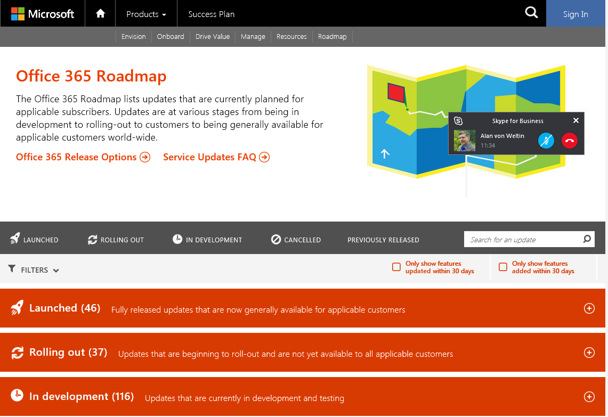

Office 365 Admin Portal Message Center
The Message Center provides information about changes that are starting to rollout to the State’s tenant. All Office 365 Service Administrators have the ability to review the Message Center messages.
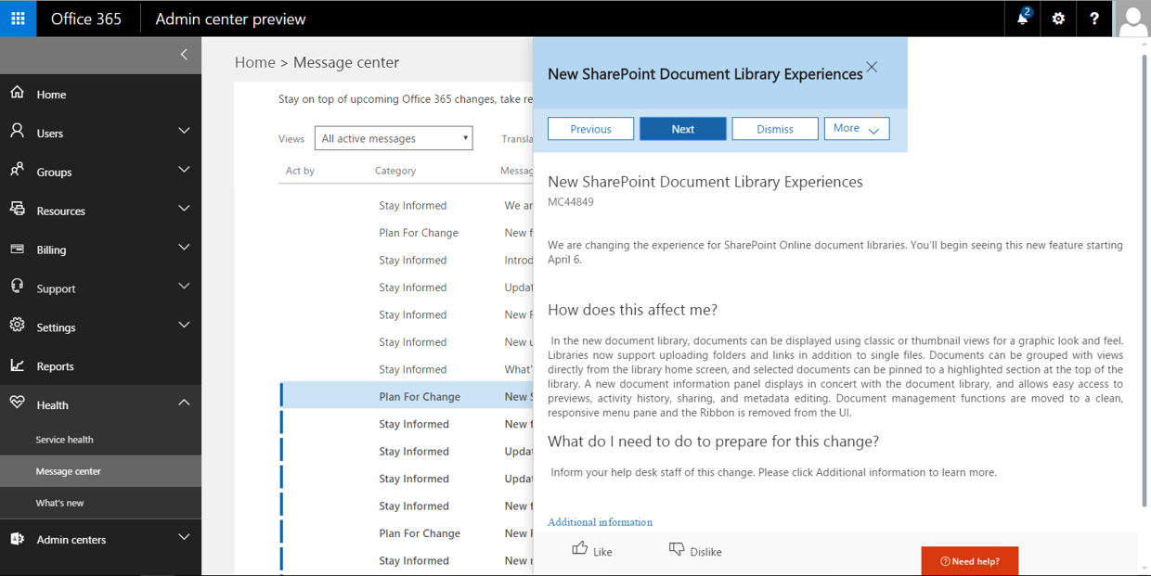

Office 365 First Release Program
Agencies can request that specific users be assigned to the Office 365 First Release Program. It is up to each Agency to determine how many users will participate in the First Release Program. This program allows selected users to receive new updates 7-14 days prior to the standard release to the tenant. To request access to first release, simply open a Cherwell request including the UPN of the User to be added to First Release.

Office 365 Service Update Management Newsletter
DET has contracted with Premier Support to get access to the Monthly NDA Roadmap that provides critical details on the feature release schedule, changes to the service description, and other important Office 365 release information.
DET will distribute this newsletter to the Office 365 CAG, however, your agency must be covered by an NDA with Microsoft. Contact your Microsoft Account Executive for assistance in completing an NDA.
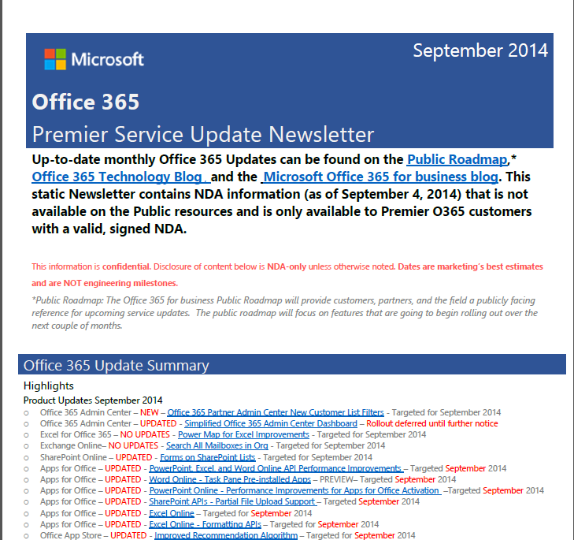

Office 365 Premier Lifecycle Management Program (Renamed Adoption Explorer)
DET has contracted (Expires 12/2016) with Premier Support to present a monthly PowerPoint to the State of Wisconsin that covers all the items in the Premier Newsletter to the Office 365 CAG.

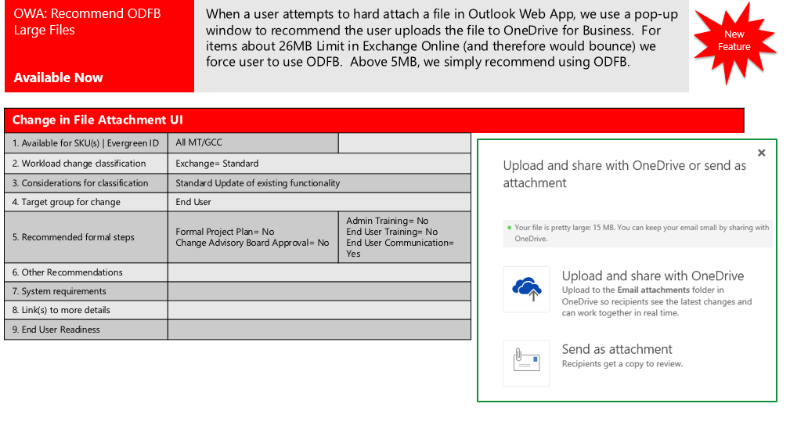

Compliance Management
Due to the various Agencies/customers serviced by (DET) and the many different laws and regulations these customers are subject to, DET must deliver secure and compliant services with common operational practices and configurations for multiple customers and jurisdictions. Given the common operational practices of the DET services, it is ultimately up to each State Agency/customer to evaluate the service offerings against their own compliance requirements to determine whether specific services satisfy their regulatory needs.
DET is committed to compliance with data protection and privacy laws generally applicable to IT service providers. Commitment is exhibited in three major areas.
- First, DET implements and maintains appropriate technical and organizational measures, internal controls, and information security practices intended to protect customer data against loss, destruction, or alteration; unauthorized disclosure or access; or unlawful destruction.
- Second, DET services are designed and operated with multiple safeguards utilizing industry-standard security and privacy best practices (i.e. National Institute of Standards and Technology (NIST) Special Publication 800-53 Security and Privacy Controls).
- Third, multiple audits are conducted annually, as independent validation, that DET complies with policies and procedures for security, privacy, continuity, and compliance.
Customers in many industries and government have found they can use Office 365 in a manner that remains in compliance with applicable regulations, provided they utilize the services in a manner appropriate to their particular circumstances. Specifically, organizations covered by IRS Publication 1075 and other regulatory requirements should have their own policies, security, and training program in place to ensure their personnel do not use Office 365 services in a way that violates the organizational or regulatory standards.
For example, an agency may store a customer list that includes federal tax information. For Office 365, Microsoft has security procedures in place to ensure that Microsoft personnel do not inappropriately access or disclose this information. However, one of the agency’s employees, who are a user of Microsoft Exchange Online, might use the service to send such a customer list to another party without appropriate consent. Any resulting violation of federal tax information protection requirements arising from Office 365 having followed the direction of the customer—namely, by causing an email to be sent in the ordinary course of providing the services—is the customer's responsibility.
DET will work with Microsoft and their Office 365 team to ensure the service offering operates under the contractual agreement, thereby helping State Agencies (Agency)/customer(s) remain compliant. Each Agency/customer subject to regulatory and statutory requirements must review the Office 365 service offering and assess if it will comply with their specific compliance requirements.

User Audit Logs & Security Incident Event Management
Microsoft retains 90 days’ worth of user log data in the cloud. This information can be searched via the Security & Compliance Center.
DET Enterprise Service Desk

Information Technology (IT) Security Policy Handbook

eDiscovery & Content Search
Microsoft has introduced new eDiscovery and content search features into the Security & Compliance Center. This new system has the ability to apply search filters so that content searches can be limited to a subset of Exchange & SharePoint Content.

Litigation Hold, In-Place Hold, Retention Policies
No retention or hold policies have been implemented.

Third Party Audit Reports
Microsoft makes third Party audit reports available to Office 365 customers via the Security & Compliance Center. Permissions to view these reports can be delegated to specific users. Currently, DET is the only agency with access to these reports.

Data Loss Prevention
No Data Loss Prevention (DLP) Policies have been put in place at this time.

Managing the License Pool
Office 365 does not provide the ability to segment and thereby prevent agencies from overconsuming licenses. Each agency will be responsible for purchasing the correct amount of Office 365 Licenses to meet their organizational requirements. However, DET will run a licensing report on a monthly basis to verify that no agency is overconsuming licenses.
Figure 2: Product Licenses Screen
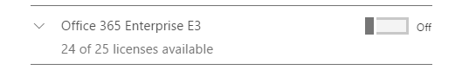
License Pool

Agency License Tracking
When an activation email is applied to the Office 365 Tenant, DET will record the additional licenses within a tracking spreadsheet. This spreadsheet will be used by business services to track how many licenses have been purchased by state agencies.

Agency License Monthly Report
DET Business Services will provide a monthly usage report to each agency regarding their use of Office 365.

Agency License Ad-Hoc Report
A CSV export is available in the New Admin Center Portal to all Service Admin Roles within Office 365. This report allows agencies to develop their own internal reports.
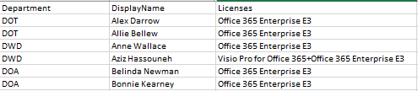

Purchasing Additional Licenses
Organizations often need to purchase additional licenses throughout the course of the year. These licenses can be purchased through their reseller and added to the tenant as needed. It is recommended that customers take into account the full length of time required to complete the purchase as a subscriber cannot begin using the product until they are fully licensed. Agencies should consider internal purchasing processes, reseller processes and the time it takes Microsoft to apply the licenses when initiating an order. Microsoft can typically apply licenses to a tenant within 1-2 weeks after receiving the order.

User Provisioning/De-Provisioning

Provisioning Process
User accounts will continue to be created using UMRA account provisioning tool. This tool will create accounts within Active Directory that are then synchronized to Azure Active Directory every 30 minutes. However, UMRA cannot apply Office 365 licenses to these accounts in the cloud. Agencies wishing to apply/remove licenses from a large number of users will complete the following steps:
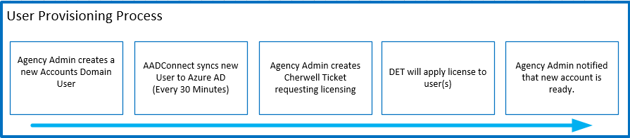

Open a Cherwell Support Ticket Requesting a Licensing Update
The ticket should include information about what type of licensing procedure that should be applied (e.g. Apply G3 License including SPO, EXO and excluding SFB). Also, a CSV file with UPN of each user must be attached to the ticket.

DET Licensing Process
Global Admins will process a PowerShell Script that will read the UPNs of the CSV provided by the agency. This script will immediately update the user with the required licenses and log the action taken.

DET will Close the ticket
DET will send the log file to the Agency and close the ticket.

Notes
- Accounts are expected to already exist within Active Directory. Agencies should continue to create users using the existing UMRA Toolset. Once created within UMRA, AAD Connect will synchronize the account into Azure Active Directory making it available for licensing.

- DET will support enabling/disabling the following subcomponents within the E3/G3 License: Office 365 ProPlus, Skype for Business, SharePoint Online and Exchange Online.
Figure 3: Typical E3 Sub-Components
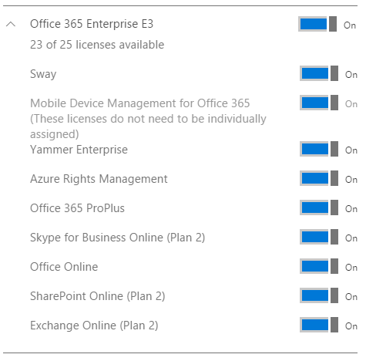
Yammer is included in the G3 suite however it is not within the GCC Boundary and will not be activated during the initial deployment. Sway is not yet available within the GCC offering.

De-Provisioning Process

Disabling a User
If a user is disabled from Active Directory, the license will remain assigned to the user and the following will occur:

Exchange Online
- User will lose access to the Mailbox (Note: Some Protocols (EWS, ActiveSync, OWA) Cache Credentials for up to 24 hours). See this article for information on disabling these features. https://support.office.com/en-us/article/Offboard-a-user-from-Office-365-44d96212-4d90-4027-9aa9-a95eddb367d1?ui=en-US&rs=en-US&ad=US

SharePoint Online
- User will lose access to SharePoint Sites & OneDrive Sites. Existing Web sessions will remain active until expiration. See the following article to invalidate all existing sessions forcing re-authentication. https://technet.microsoft.com/en-us/library/mt637161.aspx

Skype for Business Online
- Users will lose the ability to authenticate to Skype for Business

Office Pro-Plus
- Office Applications (Desktop, iPhone, Tablet) will become read-only at next subscription check.

Deleting a User
If a user is deleted from Active Directory, the license will go back into the license pool and the following will occur:

Exchange Online
- User will lose access to the Mailbox (Note: Some Protocols (EWS, ActiveSync, OWA) Cache Credentials for up to 24 hours). See this article for information on disabling these features. https://support.office.com/en-us/article/Offboard-a-user-from-Office-365-44d96212-4d90-4027-9aa9-a95eddb367d1?ui=en-US&rs=en-US&ad=US
- Mailbox will be set for permanent deletion after 30 Days.
- If a litigation hold or in-place hold policy has been applied to the mailbox, the mailbox will become inactive. Inactive mailbox contents can be viewed via eDiscovery content searches or restored via PowerShell. https://technet.microsoft.com/en-us/library/dn798632(v=exchg.150).aspx
- If mailbox contents should be accessible to non-legal/admins, consider converting the User Mailbox to a Shared Mailbox. (Note Archive/Litigation Hold features require an Exchange Plan 2 License to be assigned the Shared Mailbox)

SharePoint Online
- User will lose access to SharePoint Sites & OneDrive Sites. Existing Web sessions will remain active until expiration. See the following article to invalidate all existing sessions forcing re-authentication. https://technet.microsoft.com/en-us/library/mt637161.aspx
- SharePoint Content authored by the User will remain within Teamsite or Office 365 Group.
- The 30-day retention period for cleanup of OneDrive begins when a user account is deleted from Azure Active Directory. No other action will cause the cleanup process to occur including disablement of a user account or removal of a user’s license. For more information, go to the following Microsoft website: https://support.microsoft.com/en-us/kb/3042522
- The personal site (that is, the OneDrive for Business site) for the deleted account is sent to the site collection recycle bin. The site is deleted from the recycle bin according to the site collection recycle bin retention policy, which is 30 days. The site is not listed in the site collection recycle bin user interface (UI). You can however confirm its presence by using the Get-SPODeletedSite cmdlet for the SharePoint Online Management shell.

Skype for Business Online
- Users will lose the ability to authenticate to Skype for Business

Office Pro-Plus
- Office Applications (Desktop, iPhone, Tablet) will become read-only at next subscription check.

Removing a License from a user. (Create Inactive User)
Removing a license from an active/disabled user will follow the same Cherwell support request used for applying licenses to users. The following will occur when a license is removed from a user:

Exchange Online
- User will lose access to the Mailbox (Note: Some Protocols (EWS, ActiveSync, OWA) Cache Credentials for up to 24 hours). See this article for information on disabling these features. https://support.office.com/en-us/article/Offboard-a-user-from-Office-365-44d96212-4d90-4027-9aa9-a95eddb367d1?ui=en-US&rs=en-US&ad=US
- Mailbox will be set for permanent deletion after 30 Days.
- If a litigation hold or in-place hold policy has been applied to the mailbox, the mailbox will become inactive. Inactive mailbox contents can be viewed via eDiscovery content searches or restored via PowerShell. https://technet.microsoft.com/en-us/library/dn798632(v=exchg.150).aspx
- If mailbox contents should be accessible to non-legal/admins, consider converting the User Mailbox to a Shared Mailbox. (Note Archive/Litigation Hold features require an Exchange Plan 2 License to be assigned the Shared Mailbox)

SharePoint Online
- User will lose access to SharePoint Sites & OneDrive Sites. Existing Web sessions will remain active until expiration. See the following article to invalidate all existing sessions forcing re-authentication. https://technet.microsoft.com/en-us/library/mt637161.aspx
- SharePoint Content authored by the User will remain within Teamsite or Office 365 Group.
- The OneDrive site will remain intact until the user’s account is deleted. An OneDrive site clean-up process begins when a user account is deleted from Azure Active Directory. No other action will cause the cleanup process to occur including disablement of a user account or removal of a user’s license. (*This behavior may be modified in future SPO Updates.)

Skype for Business Online
- Users will lose the ability to authenticate to Skype for Business

Office Pro-Plus
- Office Applications (Desktop, iPhone, Tablet) will become read-only at next subscription check.

Appendix 1: SEP (Service Enablement Plan) Network: Planning, Infrastructure, Configuration

Bandwidth Planning
Several architectural factors influence an Office 365 design, but one of the key aspects of the design is the network bandwidth calculation. For each of the cloud-based services in Office 365 Service that users consume, all traffic must flow from the corporate network, across the public Internet, and into Office 365 Service.
Article below outlines this topic in greater detail:
TechNet: Network planning and performance tuning for Office 365
Note: The numbers provided in most documents are an estimation of bandwidth requirements based on assumed usage patterns during the initial planning phase.
Microsoft recommends that customers evaluate their network traffic throughout their enterprise by using bandwidth calculators for each Internet egress point. Below are references to various calculators and latency tests. The amount of total bandwidth is not expected to increase with the migration to O365 multi-tenant. What will change is the amount of traffic that is sent to the internet. O365 is an internet based service whereas the dedicated environment relies on private lines / VPNs for communication between the clients and the dedicated services. Internet will increase with the migration to O365. The Wisconsin DOA can use the aggregate bandwidth as a gauge to how bandwidth to the internet will increase.

Exchange Bandwidth Calculator
An estimate of bandwidth can be obtained using the Exchange Bandwidth Calculator:
TechNet: [Exchange Client Network Bandwidth Calculator]

Skype for Business bandwidth calculator
TechNet: [Lync 2010 and 2013 Bandwidth Calculator]
TechNet: [Lync Online - Transport Reliability IP Probe (TRIPP Tool)]

SharePoint bandwidth
There’s no bandwidth calculator for SharePoint OnLine (SPO), these articles provide information about bandwidth and SharePoint.
TechNet: [Testing WAN connections for SharePoint 2013 architectures]
TechNet: [Plan for bandwidth requirements]

Network latency test tools
In addition to bandwidth calculators/estimators, Microsoft provides some network latency tools:
NA [http://na1-fasttrack.cloudapp.net/o365nwtest]
EMEA [http://em1-fasttrack.cloudapp.net/o365nwtest]
APAC [http://ap1-fasttrack.cloudapp.net/o365nwtest]

Ports, Protocols, IP(s) and URL(s)
The list of Office 365 network assets is a dynamic list and is subject to change. Updated information is provided via an RSS feed [Web: http://onlinehelp.microsoft.com/en-us/office365-enterprises/o365ip.rss.xml]
Topic | URL
URL(s) / FQDN(s) for Office 365 | [Web: https://support.office.com/en-us/article/Office-365-URLs-and-IP-address-ranges-8548a211-3fe7-47cb-abb1-355ea5aa88a2?ui=en-US&rs=en-US&ad=US]
IP Addresses for Office 365 (IPv4)*
*Always use hyperlink this information changes regularly
IP Addresses for Office 365 (IPv6)
URL(s) / IP(s) for all Office 365 ProPlus
IP Addresses for Exchange Online datacenters
URL(s) / IP(s) for Microsoft Federation
Table 1 - Network References

IP Port requirements
The table below outlines the requirements for the specific network “Sources”, their respective “Destinations”, and the ports to allow:
Source (From) | Destination (To) | Port | Comments
Exchange Online | Exchange Hub Transport | 25 | Mail flow from Office 365 to Exchange On-Premises
Exchange Hub Transport | Exchange Online | 25 | Mail flow from Exchange On-Premises to Office 365 (there can no intermediary SMTP devices)
AAD Connect | Office 365 Service | 443 | Directory Synchronization to Office 365
Client Computers | Office 365 Service | 80,443 | Connecting to Office 365 Service

Load Balancing
Hardware load balancing should be used for all on-premises Exchange 2013 Exchange servers. Testing of the hardware load balancing and high availability (HA) scenarios should be done prior to pilot testing. Autodiscover.accounts.wistate.us is required during the migration from dedicated to 0365 multi-tenant. Once all mailboxes are migrated to O365, AutoDiscover can be moved to O365. The on premise Exchange servers will not require to be exposed to the Internet nor will load balancing services be needed at that time.

Port Exhaustion
The customer needs to ensure a strategy is in place to avoid port exhaustion. Wisconsin DOA will need to add the appropriate number of public IPs that are available and/or patch port-hungry application(s).
Current guidance suggested that a maximum of approximately 2,000 Exchange clients per IP address could be connected to Office 365 before port exhaustion. This section provides some details on this key issue, how to approximate the correct number, and some methods of resolution.

Network Address Translation (NAT)
Most corporate networks use private (RFC1918) IP address space. Private address space is allocated by Internet Assigned Numbers Authority (IANA) and intended solely for networks that do not route directly to and from the global Internet.
To provide Internet access to devices on a private IP address space, organizations use gateway technologies like firewalls and proxies that provide network address translation (NAT) and/or port address translation (PAT) services. These gateways make traffic from internal devices to the Internet (including Office 365) appear to be coming from a single publicly routable IP addresses. Each outbound connection from an internal device translates to a different source TCP port on the public IP address. In this way, thousands of people on a corporate network can “share” a few publicly routable IP addresses.

NAT limitations with Office 365
Outlook client could potentially open up between three and eight connections (depending on the version and client it could reach 14). Because there are a maximum of 64,000 ports available on a modern network devices, there can be a maximum of 8,000 users behind an IP address before the ports are exhausted. Microsoft has observed that other device types in the egress path can also be constrained at 32k and 64k levels. Such devices include DLP devices, IP intrusion detection, etc. The port count for a given client is also dependent on the other applications the user may be using (Skype for Business, Internet browsing sessions, etc. All customers should plan on a significant increase in connection count through all egress devices. Customers who use centralized egress solutions are the most vulnerable to port exhaustion issues.
The number of ports opened by the outlook client can vary with specific types of operations in outlook. Delegation scenarios for example, can cause an individual workstation to consume a large number of connections

Calculating maximum supported devices behind a single public IP address /w Office 365
To determine the maximum number of devices behind a single public IP address, you should monitor network traffic to determine peak port consumption per client. In addition, a peak factor should be used for the port usage (minimum 4). You can use the following formula to calculate the number of supported devices per IP address:
Maximum supported devices behind a single public IP address = (64,000 - restricted ports)/ (Peak port consumption + peak factor)
For instance, if 4,000 ports were restricted for use by Windows and six ports were needed per device with a peak factor of four:
Maximum supported devices behind a single public IP address = (64,000 - 4,000)/ (6 + 4) = 6,000
Note: With the release of the Office 365 hosting pack, included in the updates from September 2011 for Microsoft Office Outlook 2007, or November 2011 for Microsoft Outlook 2010, or a later update, the number of connections from Outlook (both Office Outlook 2007 with Service Pack 2 and Outlook 2010) to Exchange can be as few as 3.
To allow more than 2,000 devices behind a single public IP address, follow the steps outlined to assess the maximum number of devices that can be supported:
Monitor network traffic to determine peak port consumption per client. Following data should be collected:
- From multiple locations
- From multiple devices
- At multiple times
Collected data will be relative on patch level and version of Outlook as well as connections for delegated and shared calendars. You can determine the patch level by the Office 365 version number.
The NETSTAT command from windows command prompt can be one way to observe connection counts. Collection of connection count data on network devices is the preferred method for analysis.
To demonstrate number of open/consumed connection by your Outlook client you can do following:
Step | Result
Ctrl + Right Click Outlook icon in task bar’s notification area: | 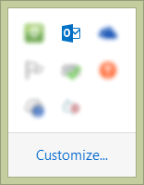
Select “Connection Status”: | 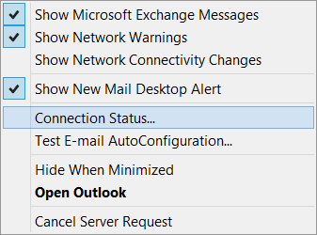
Check number of concurrent connection | 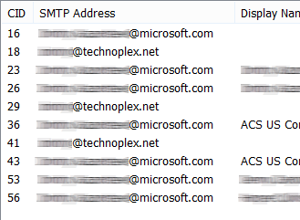
Since all users are different, this should become a scenario where you will want to “hope for the best and plan for the worst”. This is why all IP NAT/NAP numbers are *2000 (because they could be between 2,000-and 6,000).
Microsoft has observed a few cases where the default calendar sharing permissions can cause a persistent connection increase. Essentially, if an end user has configured higher than read-only privileges to their calendar, a delegate that opens their calendar will cache this calendar in their OST and maintain a connection for the synchronization of this calendar for approximately 60 days.

Mail Encryption, SSL “In Transit/Man in the middle” encryption and WAN accelerators
Microsoft Office 365 does not require you to use WAN Optimization Controller devices, however many customers have successfully used WAN devices in their environment while others had troubles and therefore prolonged their troubleshooting times. Our team finds that bypassing WAN devices generally simplifies the deployment and therefore expedites the project. Official policy and support statement can be found here:
Support: [Using WAN Optimization Controller devices with Office 365]

Inbound / Outbound Server Connections - AutoDiscover Service
In order to migrate from the dedicated environment to the O365, autodiscover.accounts.wistate.us must point to an on premise Exchange 2013 SP1 CU11 servers. It should be noted that all roles need to be installed on these servers. This is due the architecture of Exchange 2013. These servers should be load balanced with a hardware load balancing solution.

