Blue Jeans Video Services
State of Wisconsin Wireless Contract 505ENT-M22-WIRELESSPH-01
Link to the order form: https://wi.accessgov.com/doa-wi/Forms/Page/technology/doa-10821

Instructions:
- Any state agency customer should use the link Wisconsin State Employee, while authorized users such as a county or municipality should use PUBLIC USER
- State Employees will be logged in with their AD credentials. Public User may need to establish a MyWisconsin ID.
- Upon filling out the form, the customer hits “SUBMIT” it will send the request via email to the Verizon Acct Rep, Julie Pfaffle for processing.
- State Agencies, or any customer which required their organizational desktop support to load the client onto their workstations must coordinate with their local staff and comply with guidelines of their respective organizations/agency.

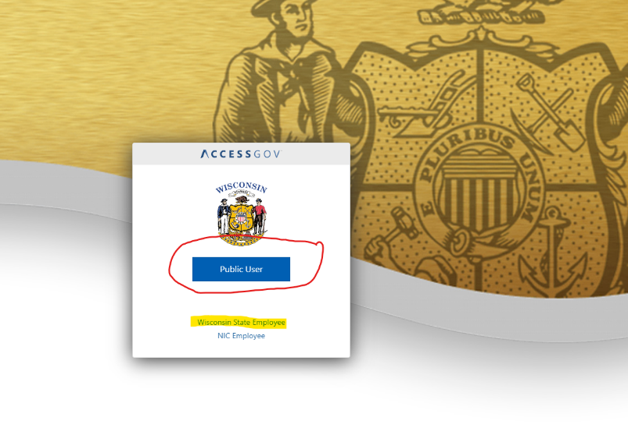
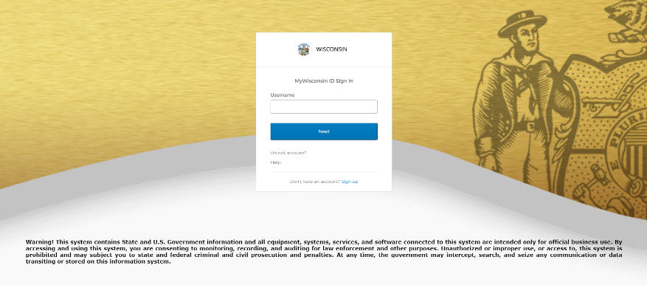

When selecting the hyperlink to the form, you will begin with this page.
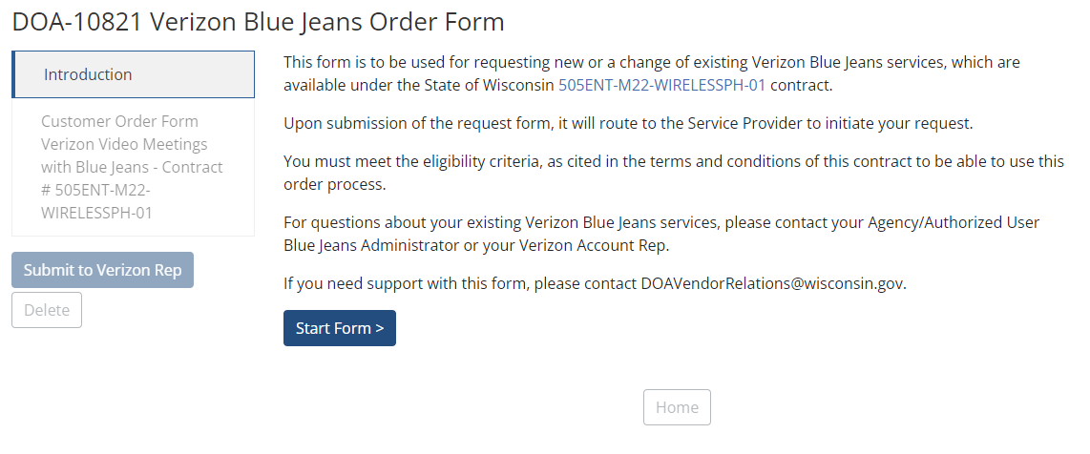
Select Start Form, complete the fields and submit.
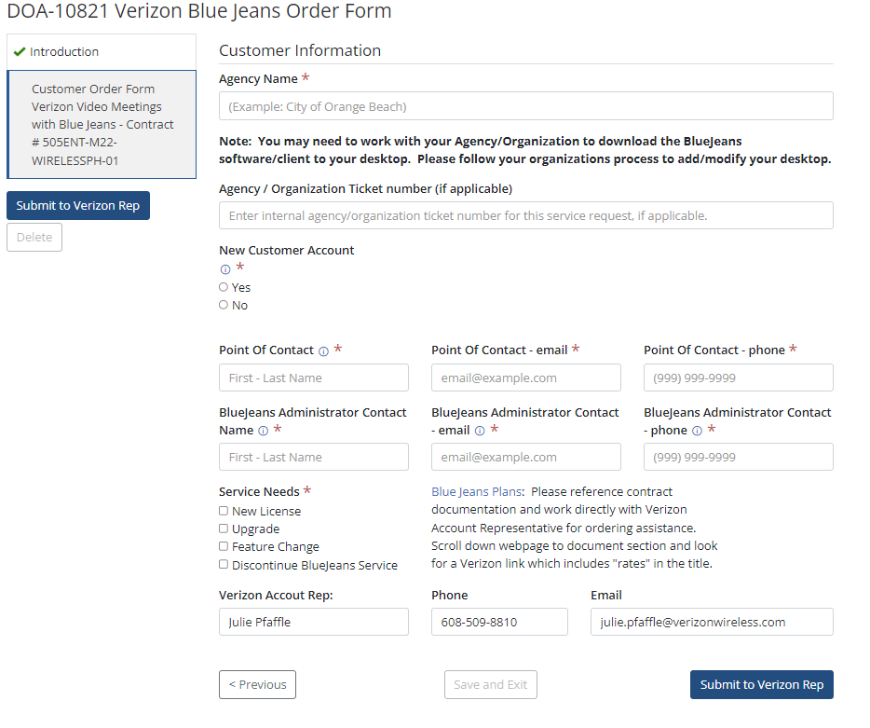

Upon successful completion and submission of the form, this will automatically email a notification to the Verizon Rep, Julie Pfaffle. You will also be able to download a copy of the form in a pdf format.
If additional assistance is needed, please reach out directly to Julie Pfaffle at Verizon. She will contact DOA/DET if form support is required.
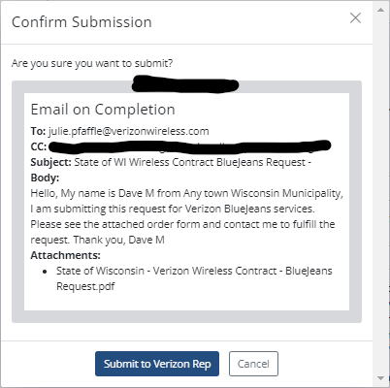

FAQs:
Form status by page. Green check means all mandatory fields completed, caution sign, additional information is required.
The red asterisk indicates a mandatory required for submission of the form.
Hover over the icon highlighted in green for additional information needed in this field.
Selection of this button will send the request to Verizon for processing.
Customer Account status: No, will request account information to proceed.
Customer Account status: Yes, will request additional information to create the account.

